**SPM NOTES**

**UNIT - I**

**Project Evaluation**

Project evaluation is an important part of software project management that allows stakeholders to assess the success of a project and identify areas for improvement. There are various approaches to project evaluation, but some common methods include:

1. Goal-based evaluation: This approach focuses on measuring the extent(Chhetra) to which project goals have been achieved. Project goals are typically defined in the project plan and can include objectives such as meeting project deadlines, staying within budget, and delivering a high-quality product.
2. Process-based evaluation: This approach focuses on evaluating the effectiveness of the project management processes and practices used throughout the project. This can include evaluating project documentation, risk management procedures, and communication processes.
3. Stakeholder-based evaluation: This approach focuses on gathering feedback from stakeholders, such as customers, team members, and project sponsors, to assess their satisfaction with the project outcomes and processes.
4. Expert-based evaluation: This approach involves seeking input from experts in the field, such as software architects or experienced project managers, to provide insights into the project's success and areas for improvement.

Regardless of the evaluation approach used, it is important to gather and analyze data throughout the project lifecycle to inform the evaluation process. This can include metrics such as project scope, schedule, budget, and quality, as well as feedback from stakeholders and team members. By conducting a thorough evaluation, project managers can identify successes and areas for improvement, which can inform future project planning and management.

Top of Form

**Benefits of Project Evaluation**

* **Better Project Management:** Project evaluation helps you easily find areas of improvement when it comes to managing your costs, tasks, resources and time.
* **Improves Team performance:** Project evaluation allows you to keep track of your team’s performance and increases accountability.
* **Better Project Planning:** Helps you compare your project baseline against actual project performance for better planning and estimating.
* **Helps with Stakeholder Management:** Having a good relationship with stakeholders is key to success as a project manager. Creating a project evaluation report is very important to keep them updated.

**Project Planning**

# **Software Project Planning**

A Software Project is the complete methodology of programming advancement from requirement gathering to testing and support, completed by the execution procedures, in a specified period to achieve intended software product.

The project planning must incorporate the major issues like size & cost estimation scheduling, project monitoring, personnel selection evaluation & risk management. To plan a successful software project, we must understand:

* Scope of work to be completed
* Risk analysis
* The resources mandatory
* The project to be accomplished
* Record of being followed

Software Project planning starts before technical work start. The various steps of planning activities are:

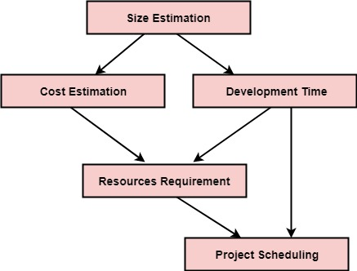

**Activities in software project management**

Software project management involves various activities throughout the software development lifecycle. Some of the common activities include:

Planning: The planning phase involves defining project goals, scope, requirements, and deadlines. It also includes creating a project schedule, allocating resources, and determining the budget.

Requirement Analysis: This phase involves understanding the project's functional and non-functional requirements and documenting them in a detailed requirements specification document.

Design: In this phase, the software architecture and design are created based on the requirements analysis. It involves creating high-level and low-level design documents, and designing the user interface.

Development: The development phase involves writing code, testing the software, and fixing bugs. This phase includes programming, debugging, unit testing, and integration testing.

Implementation: The implementation phase involves deploying the software to the production environment and making it available to users.

Monitoring and Control: In this phase, project progress is monitored against the project plan, and corrective actions are taken if there are any deviations from the plan.

Risk Management: This involves identifying potential risks and taking proactive measures to mitigate or avoid them.

Quality Assurance: This involves ensuring that the software meets the quality standards and requirements specified in the requirements document.

Documentation: Throughout the software development lifecycle, documentation is created to capture the project's progress, decisions, and outcomes.

Maintenance: After the software is implemented, maintenance activities are performed to keep the software up to date, fix bugs, and address any issues that may arise.

**\*\*\*Stepwise Project Planning\*\*\***

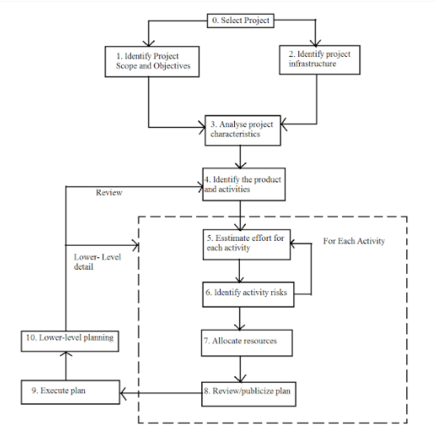

**Steps in Project Planning:**

* **Step** 0: Select **project**.
* **Step** 1: Identify **project** scope and objectives.
* **Step** 2: Identify **project** infrastructure.
* **Step** 3: Analyze **project** characteristics.
* **Step** 4: Identify **project** products and activities.
* **Step** 5: Estimate effort for each activity.
* **Step** 6: Identify activity risks.

**Step 1: Identify Project Scope and Objectives**

1.1. Identify objectives and practical measures of effectiveness in meeting those objectives .How do we know we are successful?

1.2: Establish a project authority  Who is the boss?

1.3. Stakeholder analysis – identify all stakeholders in the project and their interests  Who does what?

1.4. Modify objectives in the light of stakeholder analysis  What shall we do for the commitment of stakeholders to the project?

 1.5. Establish methods of communication with all parties  How do we stay in touch and informed?

**Step 2: Identify Project Infrastructure**

 2.1. Identify relationship between the project and strategic planning

2.2. Identify installation standards and procedures

2.3. Identify project team organization

**Step 3: Analyze Project Characteristics**

3.1. Distinguish the project as either objective- or product-driven

3.2. Analyze other project characteristics (including quality-based ones)

3.3. Identify high-level project risks

 3.4. Take into account user requirements concerning implementation

3.5. Select development methodology and life- cycle approach

3.6. Review overall resource estimates

**Step 4: Identify Project Products & Activities**

4.1. Identify and describe project products (or deliverables)

4.2. Document generic product flows

**Contract Management :**

## What is a contract?

A contract is any agreement between two or more parties where one party agrees to provide certain deliveries or services, and the other party agrees to pay for those deliveries or

services.

**Contract Management**

Contract Management, as name suggests, is a management that mainly focuses on management of contract between two or many parties and to ensure that all parties meet their respective objectives more effectively and efficiently.













**Software Process And Process Model**

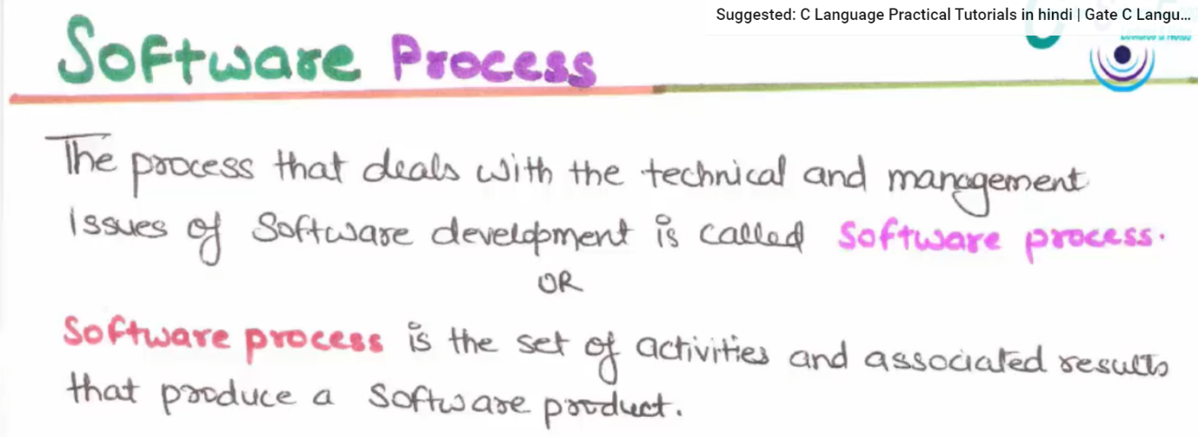

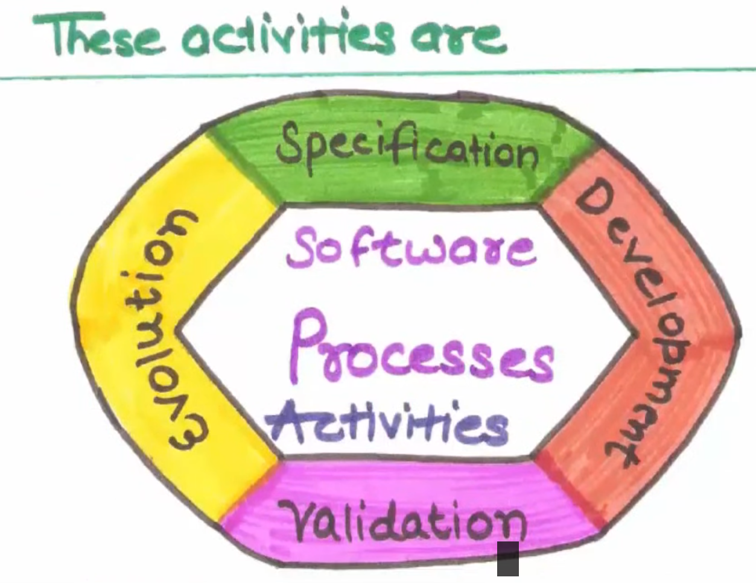

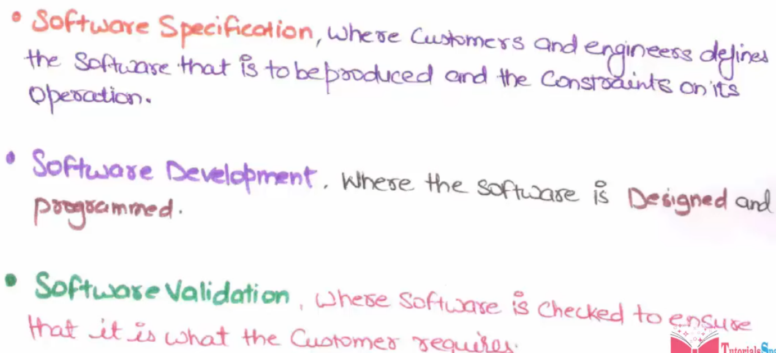



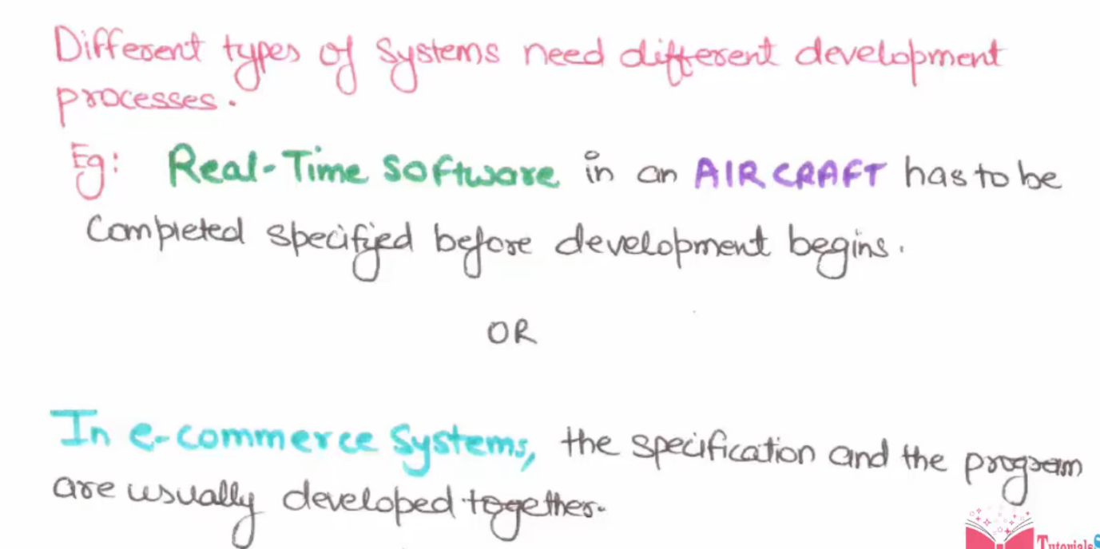

## software process model?

A software process model is a digital or hand-written model that details the software development process. Process models help provide a visual representation of the development process for both the team and the customer to review.

This helps them determine the right process to follow for specific software, identify early challenges or cost constraints and acts as a record of the team's development process for the future.

**There are many types of software process models** that development teams use across different industries. Here are some examples of typical software process models you can use to outline your development process:

### Waterfall

### 2. Prototyping

### 3. Spiral

### 4. Iterative

**Waterfall Model - Design**

Waterfall approach was first SDLC Model to be used widely in Software Engineering to ensure success of the project. In "The Waterfall" approach, the whole process of software development is divided into separate phases. In this Waterfall model, typically, the outcome of one phase acts as the input for the next phase sequentially.

The following illustration is a representation of the different phases of the Waterfall Model.

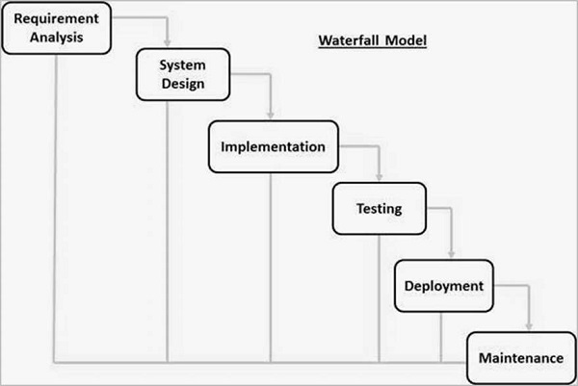

**Spiral model** is one of the most important Software Development Life Cycle models, which provides support for Risk Handling. In its diagrammatic representation, it looks like a spiral with many loops. The exact number of loops of the spiral is unknown and can vary from project to project. Each loop of the spiral is called a Phase of the software development process. The exact number of phases needed to develop the product can be varied by the project manager depending upon the project risks. As the project manager dynamically determines the number of phases, so the project manager has an important role to develop a product using the spiral model.

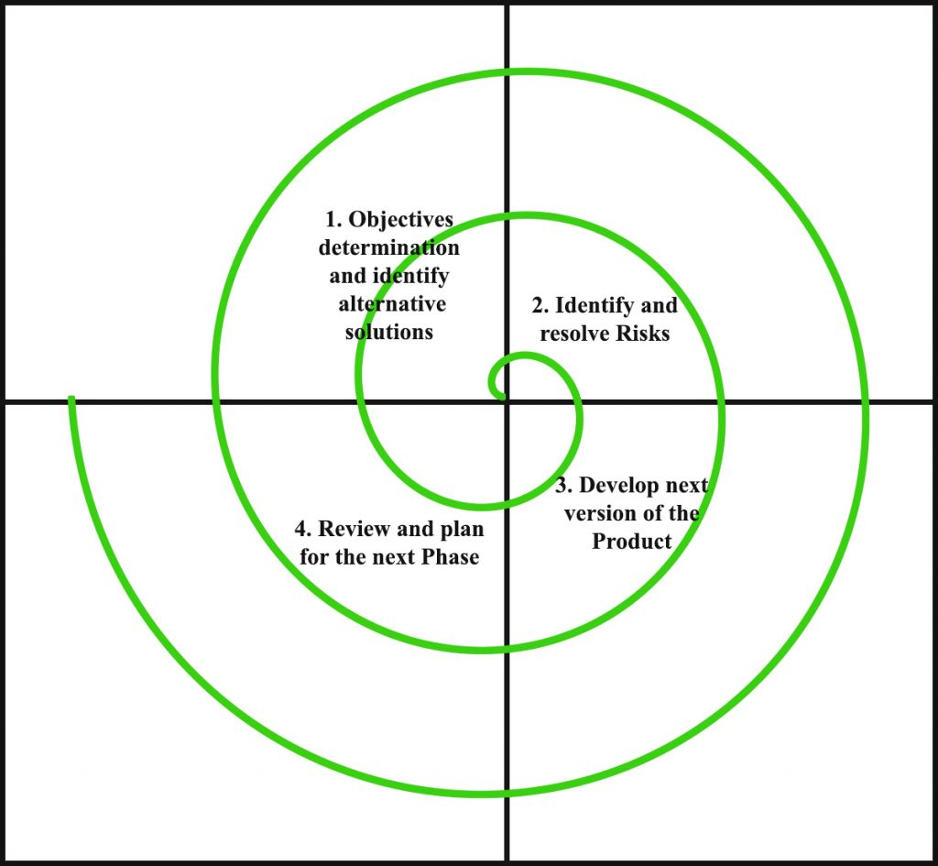

**UNIT – II**

**Cost Benefit Analysis**

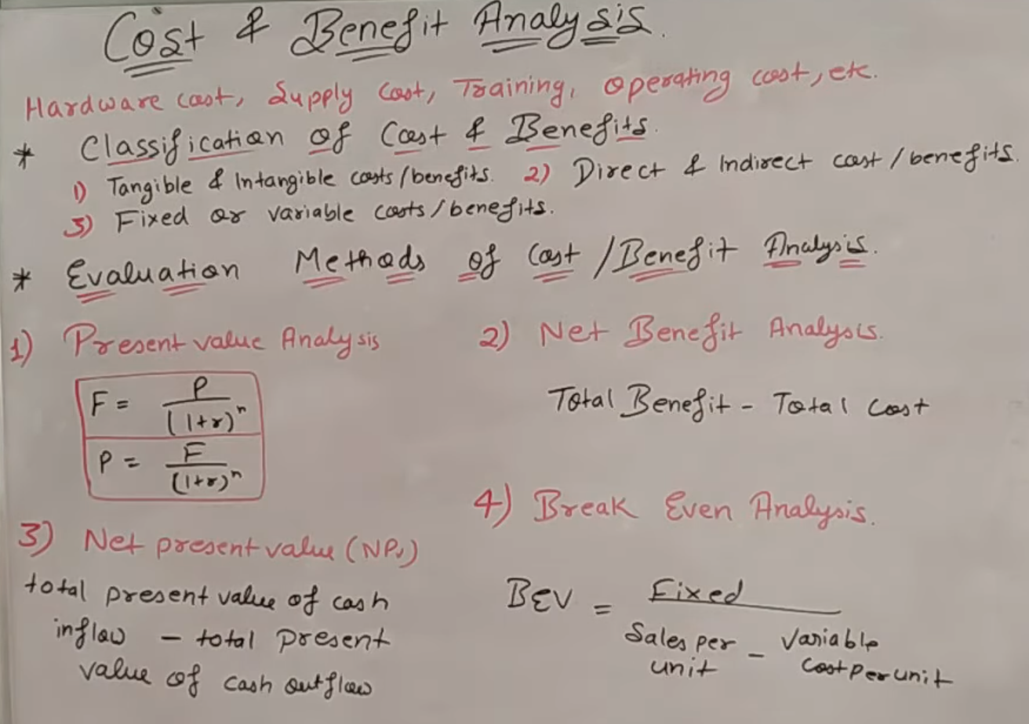

When any company develop the software then that company analies the cost which is consume by during development of software after that company analies all cost and benefits that what is benefits and what is cost.

In software developing there is need of money or cost , so when we develop any software than we analysis cost like :- Hardware cost , Supply cost , Training cost , Operating cost , etc.

* Hardware Cost:- When we buy any hardware tools to develop the software regarding to customer than we analies that what would be profit or loss during develop the software.
* Training :- When Developers gives the training to run the software Than also Developers take salary so it is a Training cost.

Like these we have supply cost , Operating cost , Hidden cost etc.

**Classification of Cost and Benefits :-**

1. **Tangible & Intangible Cost / Benefits**:- Tangible cost is direct cost like when we buy hardware to develop software. So it can directaly calculate that what is cost and benefits.

But in Intangible we can`t find direcataly cost and benefits.

Intangible Cost like:- Hidden Cost , Data Loss Cost etc.

1. **Direct & indirect Cost:-** The cost and benefits we can calculate directly.
2. **Fixed or variable cost:-** In this cost we can`t change cost .

**Cash Flow Forecasting:**

In simple words, it is the estimation of the cash flow over a period of time. It is important to do cash flow forecasting in order to ensure that the project has sufficient funds to survive. It gives an estimation that when income and expenditure will take place during the software project’s life cycle. It must be done time to time especially for start-ups and small enterprises. However, if the cash flow of the business is more stable then forecasting cash flow weekly or monthly is enough.

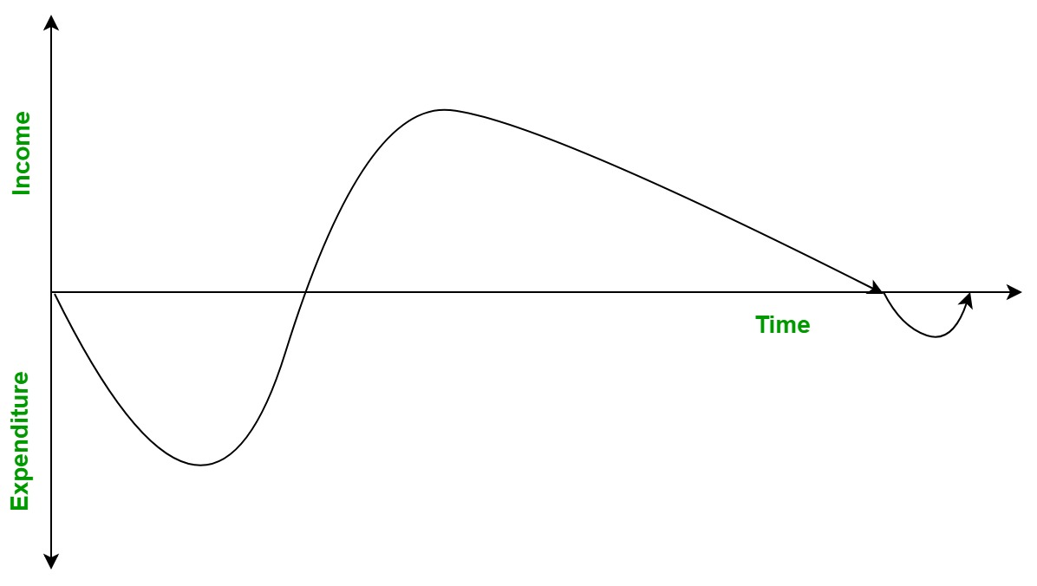

**Cash flow is of two types:**

1. **Positive Cash Flow:**

If an organisation expects to receive income more than it spends then it is said to have a positive cash flow and the company will never go low on funds for the software project’s completion.

1. **Negative Cash Flow:**

If an organisation expects to receive income less than it spends then it is said to have a negative cash flow and the company will go low on funds for the software project’s completion in future.

**Importance of Cash Flow Forecasting:**

It allows the management to plan the expenditures based upon the income in future.

It helps the organization to analyse its expenditures and incomes.

Makes sure that the company can afford to pay the employees and suppliers.

Helps in financial planning.

**Cost-benefit evaluation**

Cost-benefit evaluation is a process of analyzing the potential costs and benefits of a project or decision in order to determine whether it is worthwhile to proceed with it. This type of evaluation is typically used in business, economics, and public policy to assess the value of a particular investment or initiative.

The process of cost-benefit evaluation involves identifying all of the potential costs and benefits associated with a particular project or decision, and then quantifying those costs and benefits in monetary terms. This can involve estimating the costs of labor, materials, and other resources, as well as the potential revenues or other benefits that the project may generate.

Once all of the costs and benefits have been identified and quantified, they can be compared to determine whether the benefits outweigh the costs. If the benefits are greater than the costs, the project or decision is considered to be cost-effective, and it may be recommended for implementation. If the costs outweigh the benefits, the project may not be feasible or may need to be modified in some way to improve its cost-effectiveness.

Overall, cost-benefit evaluation is a valuable tool for decision-making, as it provides a systematic and objective way to assess the potential value of a particular project or decision.

**Risk Evaluation**

Risk evaluation is the process of assessing the potential risks that could impact the success of a project and determining the likelihood and potential impact of those risks. This process is an essential part of project management, as it helps project managers identify potential problems before they occur and develop plans to mitigate or avoid them.

The first step in risk evaluation is to identify all of the potential risks that could impact the project. This could include risks related to project scope, budget, timeline, resources, stakeholders, and other factors. Once all of the potential risks have been identified, the next step is to assess the likelihood and potential impact of each risk. This involves analyzing the probability of each risk occurring and the potential impact it could have on the project's objectives, timeline, budget, or other factors.

Once the likelihood and potential impact of each risk have been evaluated, the next step is to develop a risk management plan. This plan outlines strategies for mitigating or avoiding each identified risk, including contingency plans for dealing with any risks that do occur. The risk management plan should be regularly reviewed and updated throughout the course of the project to ensure that it remains relevant and effective.

Overall, risk evaluation is an essential part of project management, as it helps project managers identify potential problems and develop plans to mitigate or avoid them. By effectively managing risks, project managers can increase the likelihood of project success and minimize the potential impact of any unforeseen events.

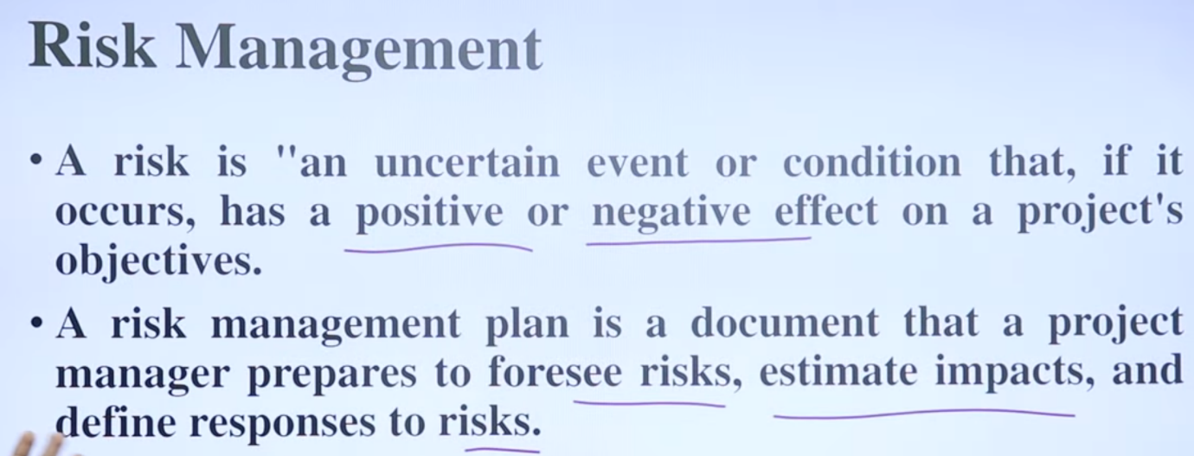

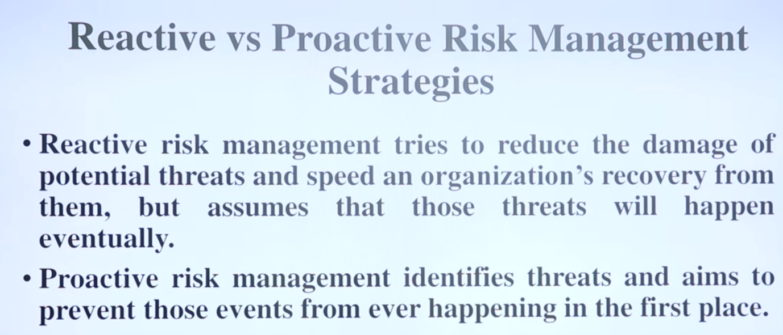

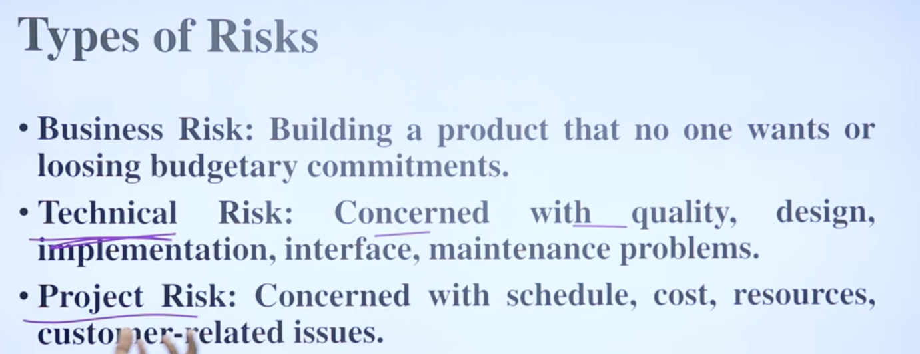

**Project costing**

**Project costing** in software project management refers to the process of estimating the total cost required to complete a software project, from inception to delivery. This includes all the costs associated with the project such as labor, equipment, materials, software, licenses, training, and any other expenses that may be incurred.

Estimating the cost of a software project accurately is important for several reasons. Firstly, it helps in determining the feasibility of the project by ensuring that the project can be completed within the budget constraints. Secondly, it enables the project manager to allocate resources effectively and efficiently. Thirdly, it helps in tracking the project's progress against the budget and making necessary adjustments to keep the project on track.

There are several methods for estimating project costs in software project management. One of the most common methods is the bottom-up estimation technique, where the project is broken down into smaller tasks, and the cost of each task is estimated individually. Another method is the top-down estimation technique, where the overall cost of the project is estimated based on the previous experience of similar projects or industry standards.

Regardless of the method used, accurate project costing is crucial for the success of any software project. It helps to ensure that the project is completed on time and within budget, while meeting all the required specifications and quality standards.

**COCOMO-II**

COCOMO-II is the revised version of the original Cocomo (Constructive Cost Model) and is developed at University of Southern California. It is the model that allows one to estimate the cost, effort and schedule when planning a new software development activity.

It consists of three sub-models:

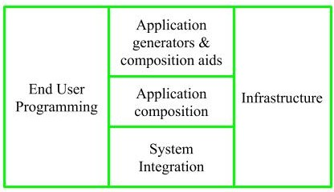

1. End User Programming:

Application generators are used in this sub-model. End user write the code by using these application generators.

Example – Spreadsheets, report generator, etc.

2. Intermediate Sector:

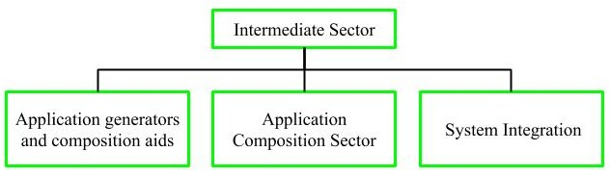

(a). Application Generators and Composition Aids –

This category will create largely prepackaged capabilities for user programming. Their product will have many reusable components. Typical firms operating in this sector are Microsoft, Lotus,

Oracle, IBM, Borland, Novell.

(b). Application Composition Sector –

This category is too diversified and to be handled by prepackaged solutions. It includes GUI, Databases, domain specific components such as financial, medical or industrial process control packages.

(c). System Integration –

This category deals with large scale and highly embedded systems.

3. Infrastructure Sector:

This category provides infrastructure for the software development like Operating System, Database Management System, User Interface Management System, Networking System, etc.

Stages of COCOMO II:

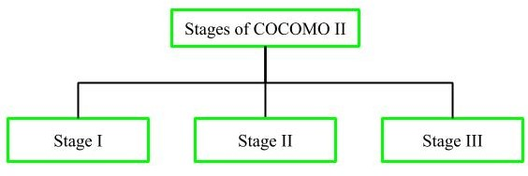

Stage-I:

It supports estimation of prototyping. For this it uses Application Composition Estimation Model. This model is used for the prototyping stage of application generator and system integration.

Stage-II:

It supports estimation in the early design stage of the project, when we less know about it. For this it uses Early Design Estimation Model. This model is used in early design stage of application generators, infrastructure, system integration.

Stage-III:

It supports estimation in the post architecture stage of a project. For this it uses Post Architecture Estimation Model. This model is used after the completion of the detailed architecture of application generator, infrastructure, system integration.

**Staffing Pattern**

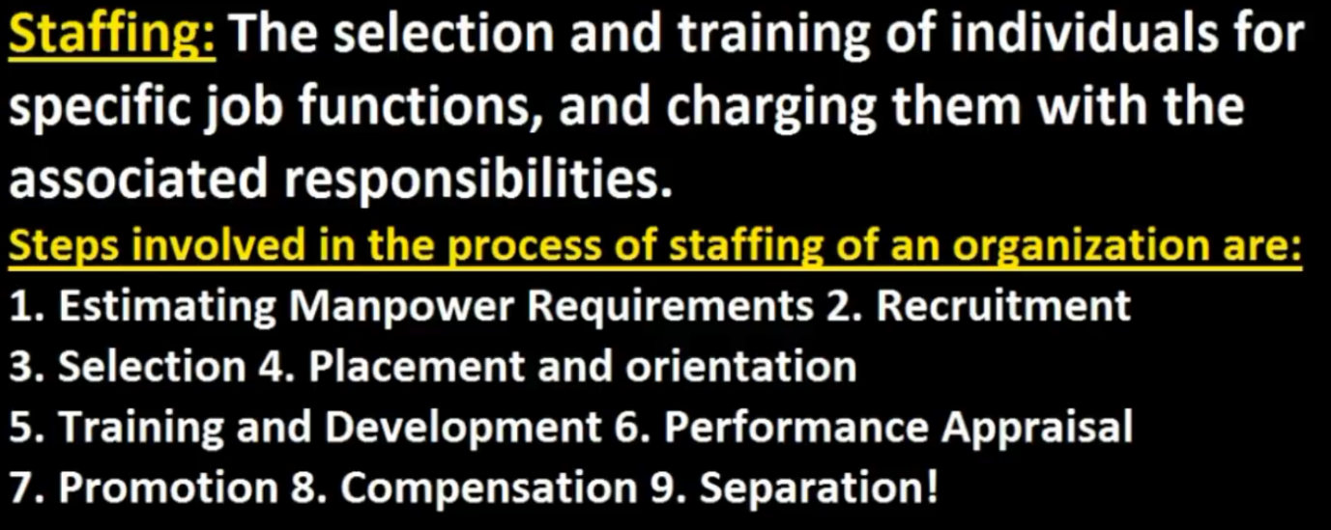

[**https://youtu.be/72KzrbcEf4E**](https://youtu.be/72KzrbcEf4E)

**Schedule Comprision**

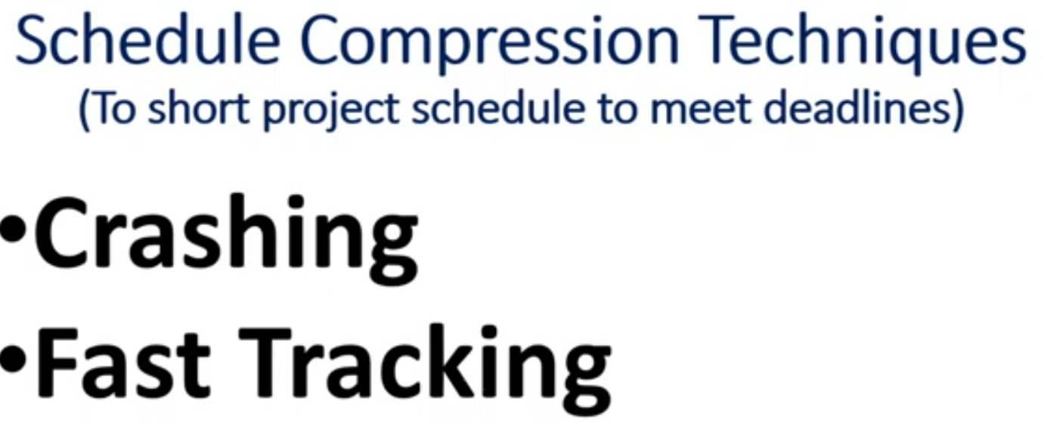

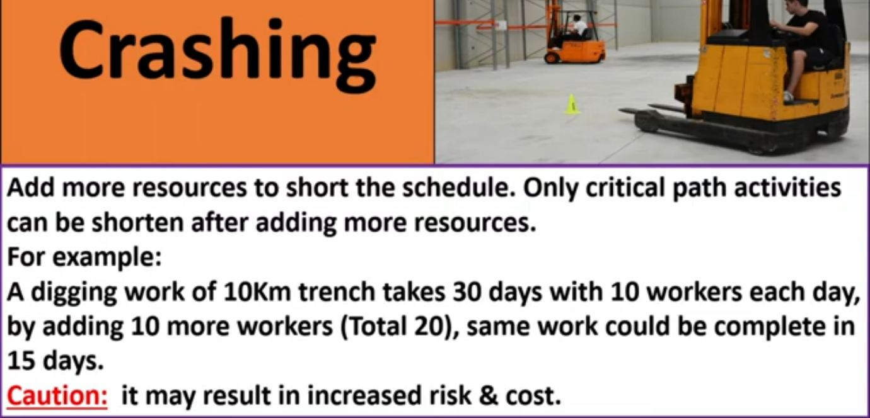

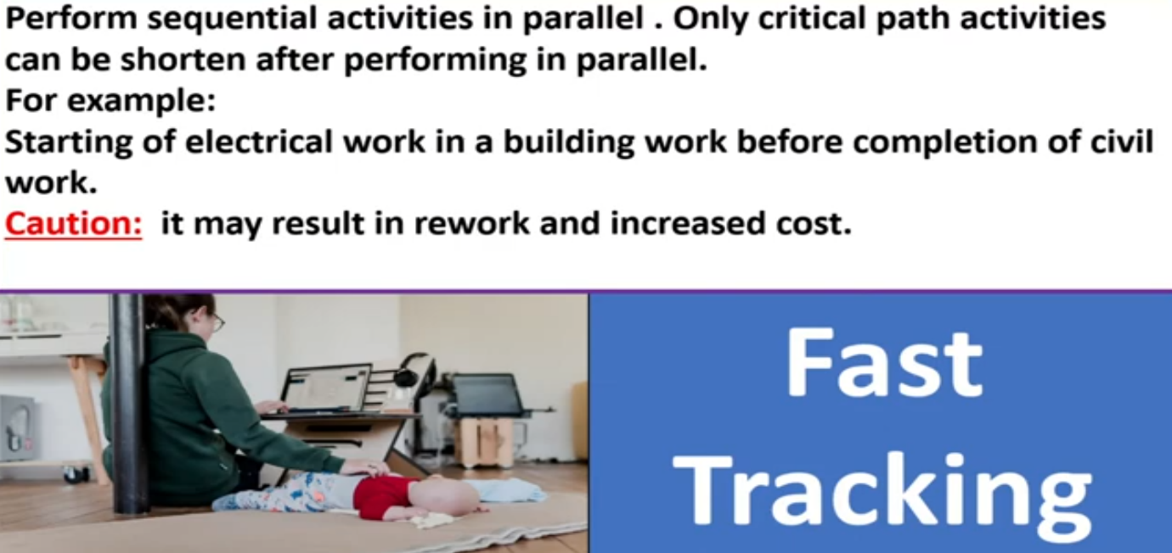

**Putnam`s Equation**

The Lawrence Putnam model describes the time and effort requires finishing a software project of a specified size. Putnam makes a use of a so-called The Norden/Rayleigh Curve to estimate project effort, schedule & defect rate as shown in fig:

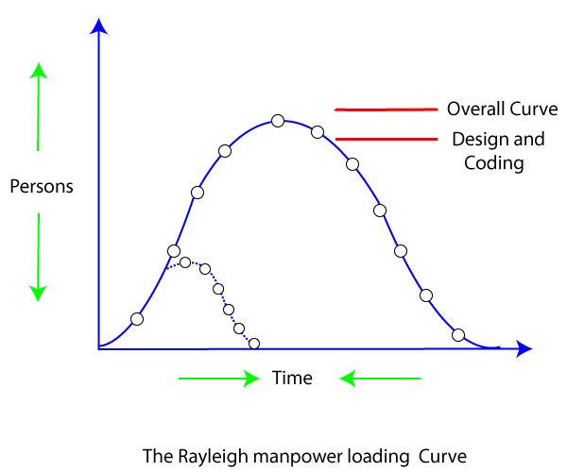

Putnam noticed that software staffing profiles followed the well known Rayleigh distribution. Putnam used his observation about productivity levels to derive the software equation:



Effect of a Schedule change on Cost

**Putnam derived the following expression:**



Where, **K** is the total effort expended (in PM) in the product development

**L** is the product size in KLOC

**td** corresponds to the time of system and integration testing

**Ck** Is the state of technology constant and reflects constraints that impede the progress of the program

**Capers Jones' Estimating Rule of Thumb**

The Capers Jones' Estimating Rule of Thumb for software project management is a set of guidelines for estimating software development projects. Capers Jones is a renowned expert in the field of software engineering, and his rule of thumb is widely used in the industry.

The rule of thumb suggests that software development projects can be estimated using the following formula:

Total effort = 2.5 * (size of the project)^1.3

Where:

Total effort is the total amount of effort (measured in person-months) required to complete the project

Size of the project is the estimated size of the software product (measured in thousands of lines of code)

The formula assumes a productivity rate of approximately 8 lines of code per person-hour, and it takes into account the fact that larger projects require proportionally more effort than smaller ones.

It's important to note that the Capers Jones' Estimating Rule of Thumb is only a rough guideline, and actual project estimates may vary based on a number of factors, including the complexity of the software, the skills and experience of the development team, and the tools and technologies being used. Therefore, it's always a good idea to supplement this rule of thumb with additional data and analysis to arrive at a more accurate estimate for a specific project.

**UNIT - III**

**Project Sequencing**

In software project management, project sequencing refers to the process of determining the order in which tasks or activities should be performed to complete a software development project. It involves identifying dependencies between tasks, estimating the time required to complete each task, and allocating resources to ensure that the project is completed on time and within budget.

Project sequencing is critical in software project management because it helps in identifying the critical path, which is the sequence of tasks that must be completed on time to ensure that the project is completed on schedule. The critical path determines the minimum time required to complete the project and identifies the tasks that require the most attention to ensure that the project is completed on time.

The following are some common tasks that may be included in project sequencing in software project management:

Requirements gathering: Identify the needs of the stakeholders and the requirements for the software.

Design and architecture: Create a detailed plan for the software architecture and design.

Coding and development: Write code to implement the design and architecture.

Testing and quality assurance: Test the software to ensure that it meets the requirements and is free of bugs.

Deployment and maintenance: Install the software and provide ongoing maintenance and support.

By effectively sequencing and scheduling these tasks, project managers can ensure that software development projects are completed on time, within budget, and meet the requirements of the stakeholders.

**Project sequencing activities**

In software project management, project sequencing activities refer to the specific steps that are taken to determine the order in which tasks or activities should be performed to complete a software development project. These activities include:

Identifying project tasks: The first step in project sequencing activities is to identify all the tasks that are required to complete the project. These tasks may include requirements gathering, design and architecture, coding and development, testing and quality assurance, and deployment and maintenance.

Defining task dependencies: Once all the tasks have been identified, the next step is to determine which tasks are dependent on others. For example, coding and development cannot begin until the design and architecture phase is complete.

Creating a work breakdown structure (WBS): The WBS is a hierarchical decomposition of the project tasks into smaller, more manageable components. The WBS helps to organize the project tasks and identify dependencies between them.

Developing a network diagram: The network diagram is a graphical representation of the project tasks and their dependencies. The network diagram can be used to identify the critical path, which is the sequence of tasks that must be completed on time to ensure that the project is completed on schedule.

Estimating task durations: The next step is to estimate the time required to complete each task. This can be done by consulting with subject matter experts, reviewing historical data, and using project management software tools.

Allocating resources: Once the task durations have been estimated, the next step is to allocate resources to each task. This may include personnel, equipment, and materials.

Developing a project schedule: The final step is to develop a project schedule that outlines the start and end dates for each task. The project schedule should take into account task dependencies, estimated task durations, and resource allocations.

By following these project sequencing activities, project managers can ensure that software development projects are completed on time, within budget, and meet the requirements of stakeholders.

**Project Scheduling Activities**

In software project management, project scheduling activities refer to the process of allocating resources and time to complete the tasks or activities identified in project sequencing. Project scheduling involves creating a timeline for the project that includes start and end dates for each task, as well as deadlines for the overall project.

The following are some common project scheduling activities in software project management:

Task duration estimation: Estimate the time required to complete each task or activity identified in project sequencing. This may involve consulting with the team members responsible for completing the tasks and taking into account any dependencies between tasks.

Resource allocation: Identify the resources required to complete each task, including personnel, equipment, and materials. Allocate resources to each task based on the estimated duration and priority of the task.

Schedule development: Use the estimated task durations and resource allocations to create a timeline for the project. The schedule should include start and end dates for each task, as well as deadlines for the overall project.

Schedule monitoring and adjustment: Regularly monitor the progress of the project against the schedule and make adjustments as needed. This may involve re-allocating resources, adjusting task durations, or revising the overall timeline for the project.

Effective project scheduling is essential in software project management because it helps to ensure that the project is completed on time and within budget. By carefully estimating task durations, allocating resources appropriately, and monitoring the progress of the project, project managers can identify and address any issues that may arise and keep the project on track.

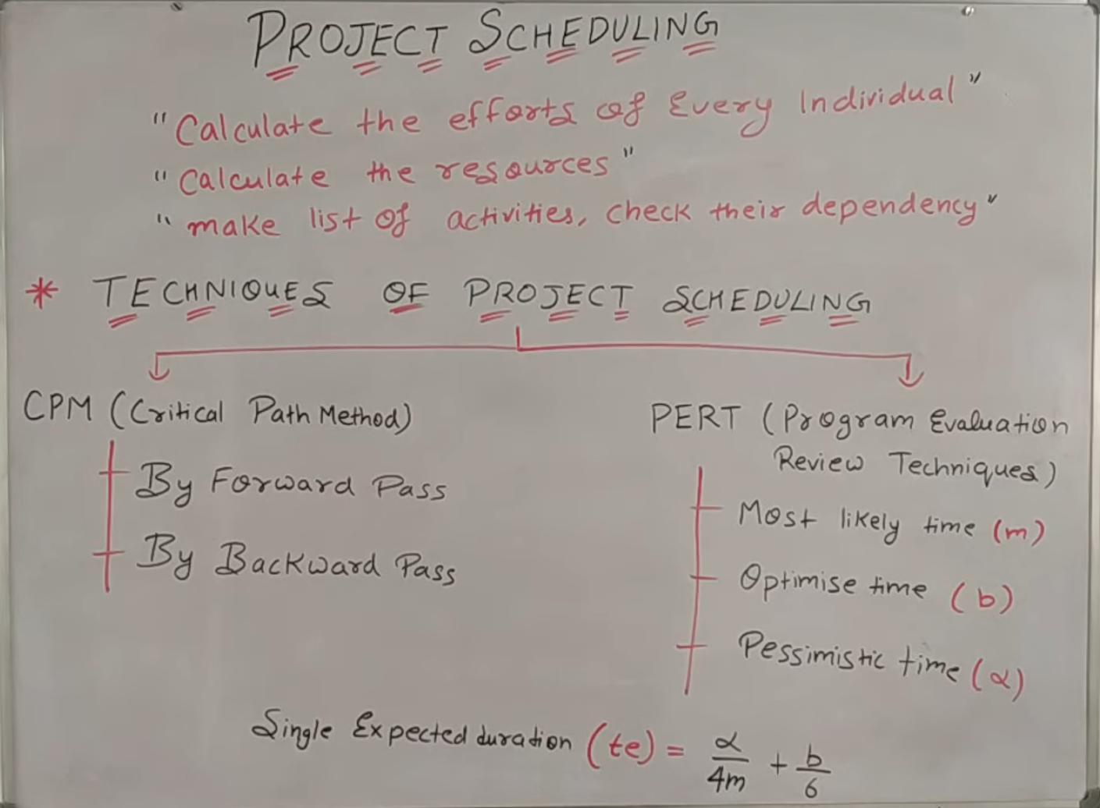

**Scheduling Resources**

Scheduling resources is an important aspect of project management that involves identifying, allocating, and managing resources such as people, equipment, and materials to complete a project within a defined timeline and budget.

Here are some steps that can help in scheduling resources in project management:

Define project scope and objectives: This step involves defining the project scope, objectives, and deliverables. This information helps in identifying the resources required for the project.

Identify resource requirements: Once the project scope and objectives are defined, the next step is to identify the resources required to complete the project. This includes identifying the number of people required, equipment, materials, and other resources.

Allocate resources: After identifying the resources required, the next step is to allocate them to specific tasks and activities in the project plan. This involves assigning tasks to specific team members, scheduling equipment and material deliveries, and other resource allocation tasks.

Create a resource schedule: Once the resources have been allocated, the next step is to create a resource schedule that outlines the availability of each resource and the tasks they will be working on. This helps in avoiding conflicts and ensures that the resources are used efficiently.

Monitor and adjust the schedule: Project managers should monitor the resource schedule and make adjustments as necessary. This includes reassigning resources, adjusting the project timeline, or reallocating resources to different tasks or activities as needed.

By following these steps, project managers can effectively schedule resources and ensure that the project is completed within the defined timeline and budget.

**Critical Path Analysis/Critical Path Method**

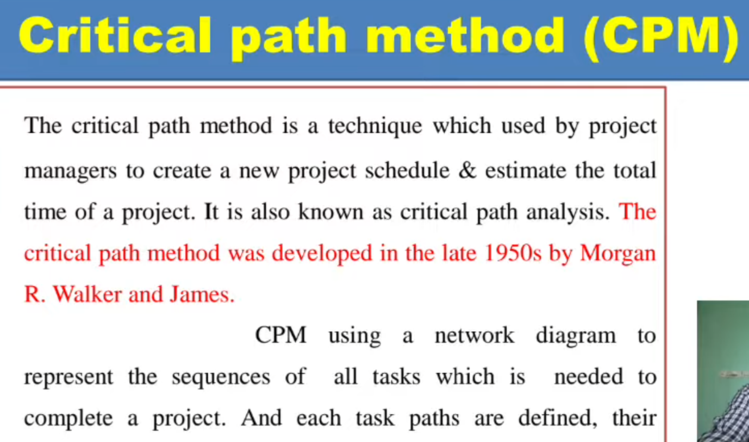

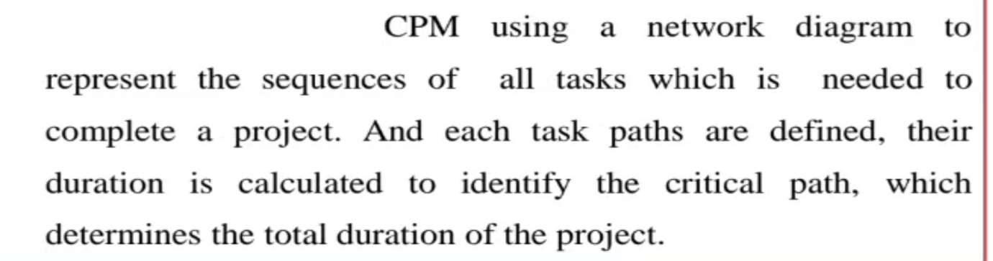

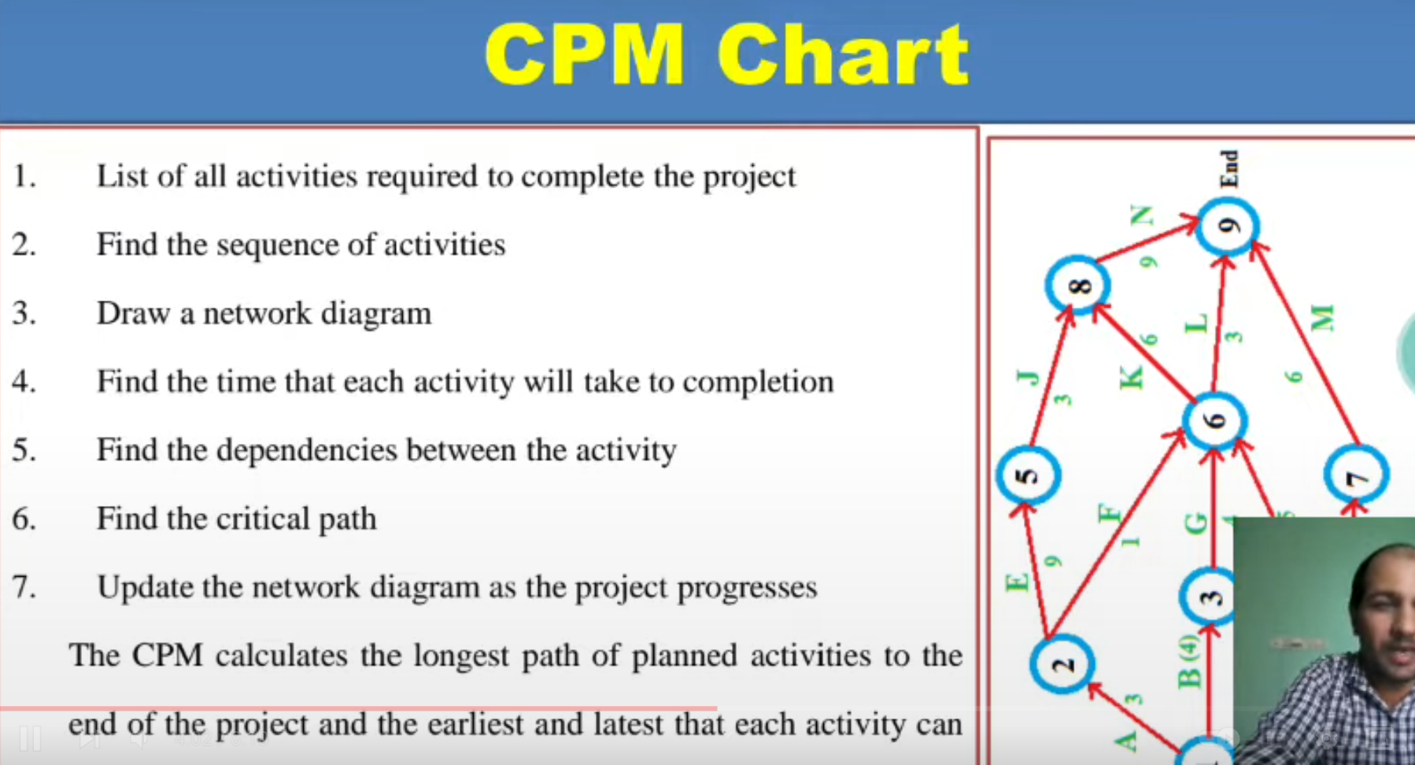



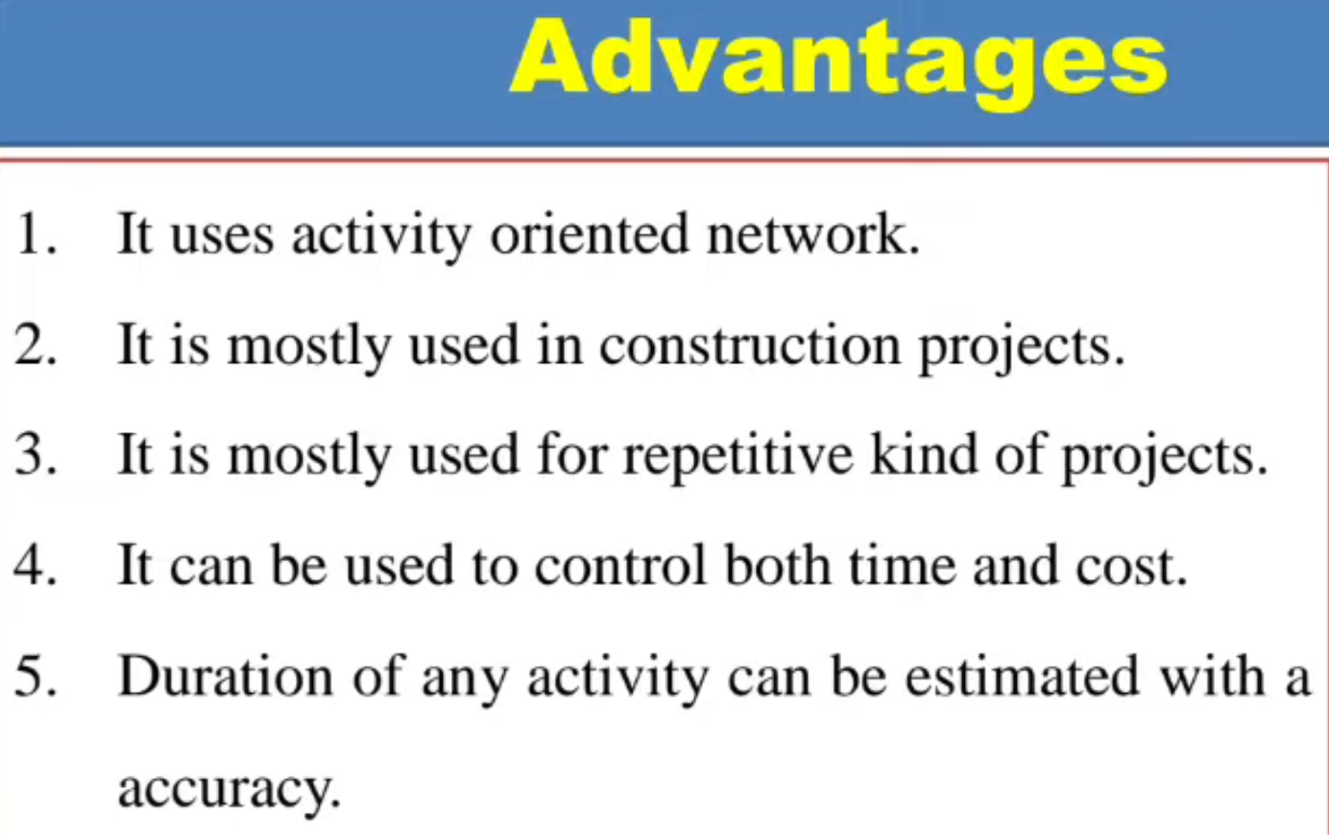

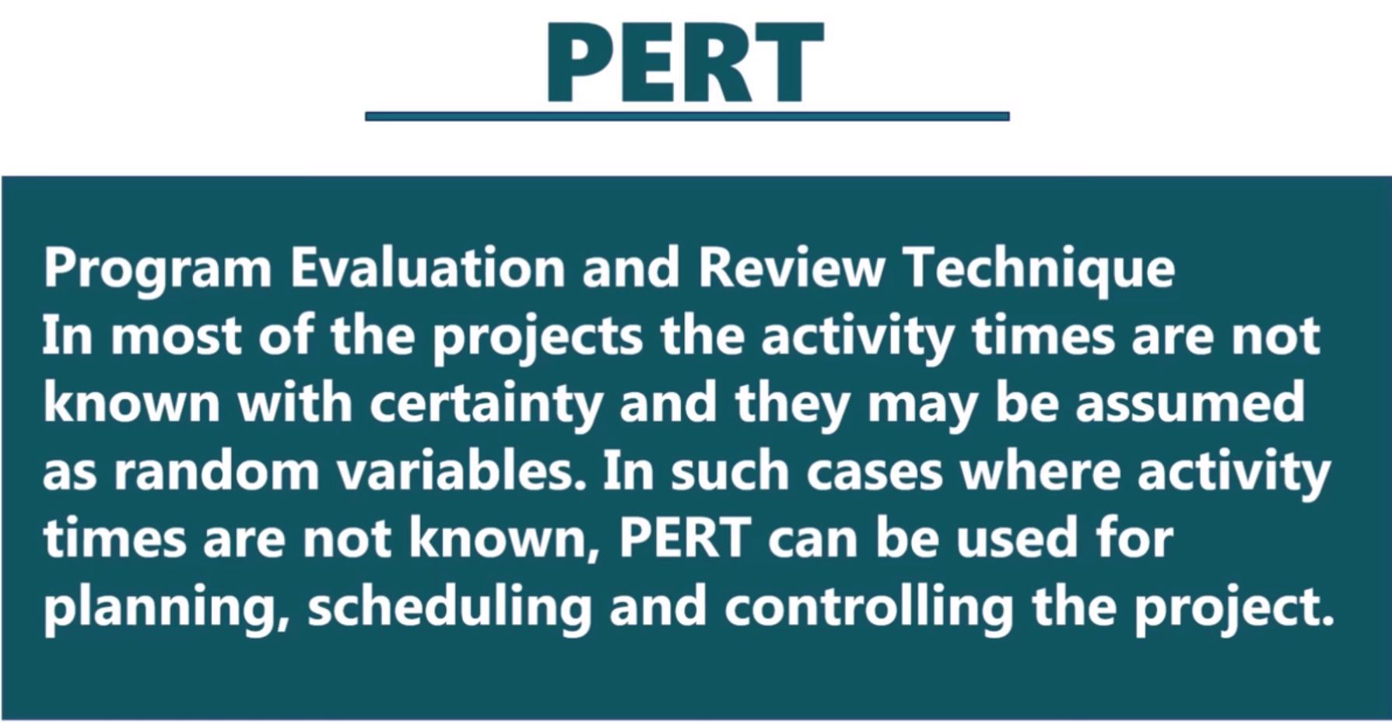

PERT Doesn`t know compelition time of project . It is a technique to schedule project in Project management.

**Risk Management**

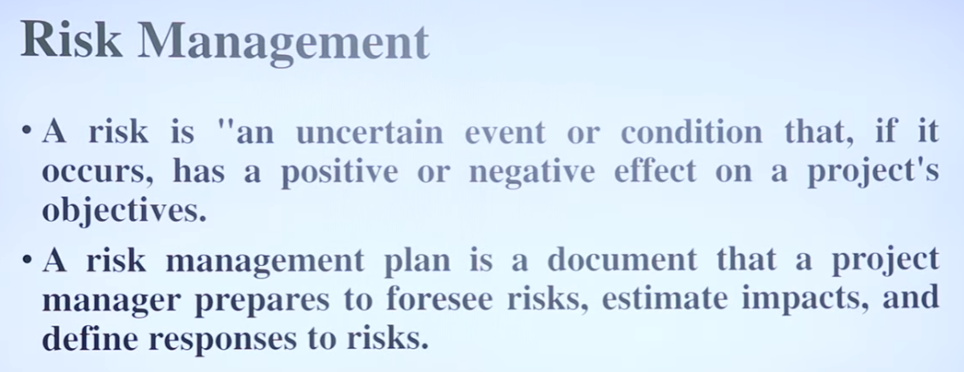

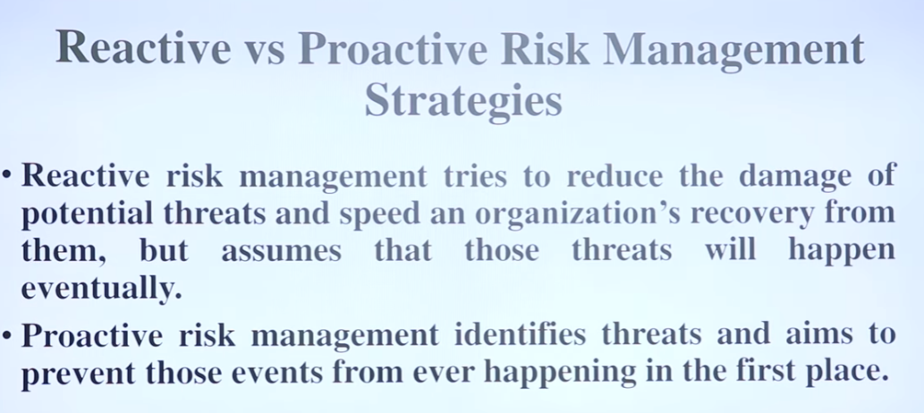

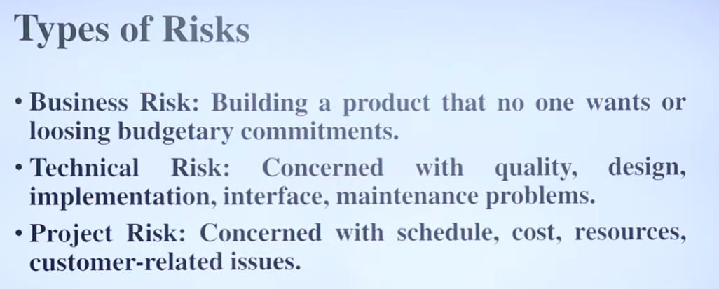

**Type of Risk:-**

1. Schedule Risk
2. Budget Risk
3. Programmatic Risks

# **Project Risk Management**

ntroduction

Risk is inevitable in a business organization when undertaking projects. However, the project manager needs to ensure that risks are kept to a minimal. Risks can be mainly divided between two types, negative impact risk and positive impact risk.

Not all the time would project managers be facing negative impact risks as there are positive impact risks too. Once the risk has been identified, project managers need to come up with a mitigation plan or any other solution to counter attack the risk.

Project Risk Management

Managers can plan their strategy based on four steps of risk management which prevails in an organization. Following are the steps to manage risks effectively in an organization:

* Risk Identification
* Risk Quantification
* Risk Response
* Risk Monitoring and Control

Let's go through each of the step in project risk management:

Risk Identification

Managers face many difficulties when it comes to identifying and naming the risks that occur when undertaking projects. These risks could be resolved through structured or unstructured brainstorming or strategies. It's important to understand that risks pertaining to the project can only be handled by the project manager and other stakeholders of the project.

Risks, such as operational or business risks will be handled by the relevant teams. The risks that often impact a project are supplier risk, resource risk and budget risk. Supplier risk would refer to risks that can occur in case the supplier is not meeting the timeline to supply the resources required.

Resource risk occurs when the human resource used in the project is not enough or not skilled enough. Budget risk would refer to risks that can occur if the costs are more than what was budgeted.

Risk Quantification

Risks can be evaluated based on quantity. Project managers need to analyze the likely chances of a risk occurring with the help of a matrix.

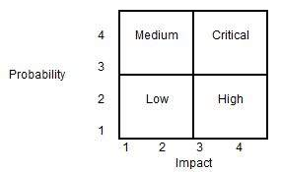

Using the matrix, the project manager can categorize the risk into four categories as Low, Medium, High and Critical. The probability of occurrence and the impact on the project are the two parameters used for placing the risk in the matrix categories. As an example, if a risk occurrence is low (probability = 2) and it has the highest impact (impact = 4), the risk can be categorized as 'High'.

Risk Response

When it comes to risk management, it depends on the project manager to choose strategies that will reduce the risk to minimal. Project managers can choose between the four risk response strategies, which are outlined below.

* Risks can be avoided
* Pass on the risk
* Take corrective measures to reduce the impact of risks
* Acknowledge the risk

Risk Monitoring and Control

Risks can be monitored on a continuous basis to check if any change is made. New risks can be identified through the constant monitoring and assessing mechanisms.

**Hazard Identification**

Hazard identification in software project management refers to the process of identifying potential risks or hazards that may arise during the development, deployment, or maintenance of a software project. These risks or hazards can be either internal or external to the project, and they can have various negative impacts on the project, such as delays, cost overruns, or security breaches.

The hazard identification process typically involves a systematic approach that includes identifying, assessing, and prioritizing potential hazards or risks. This can be done by analyzing the project's requirements, architecture, and design, as well as its operational and organizational context.

Once the hazards have been identified and assessed, the project team can develop mitigation strategies to reduce the likelihood or impact of these hazards. These strategies may include contingency planning, risk avoidance, risk transfer, or risk acceptance.

Hazard identification is a critical part of software project management as it helps project managers and stakeholders to proactively identify and mitigate potential risks before they become serious issues.

**Hazard Analysis**















**Risk Control vs Risk Mitigation**

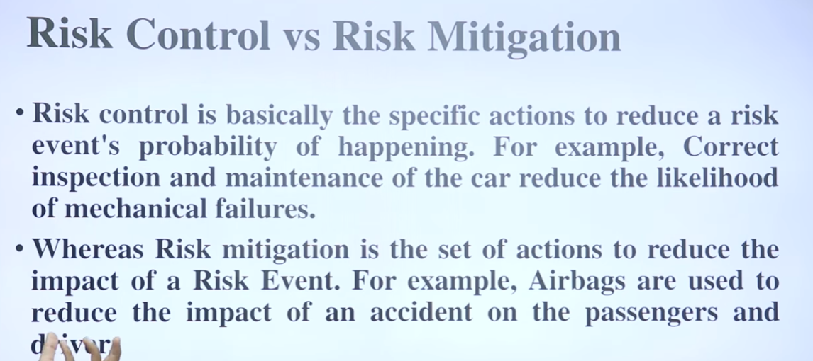

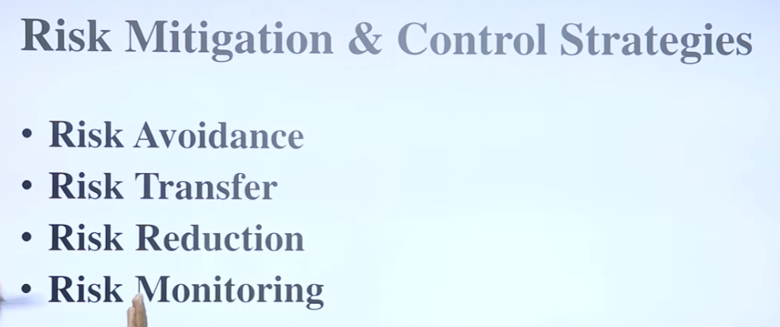

**Risk Planning:-**

Risk planning is the process of identifying, analyzing, and managing potential risks that may impact a project, organization, or individual. The goal of risk planning is to minimize or mitigate the negative impact of risks and to maximize opportunities that may arise from them.

Overall, risk planning is a critical component of project management and business strategy. By proactively identifying and addressing potential risks, organizations can improve their chances of success and avoid costly and damaging setbacks.

## Monte Carlo Analysis

## In a Monte Carlo simulation, project managers identify the key variables that can impact the project outcomes, such as project duration, cost, and resource availability. They assign probability distributions to these variables based on historical data or expert judgment.

## The simulation model then runs multiple iterations, randomly selecting values for each variable based on their assigned probability distributions. Each iteration produces a possible outcome for the project, allowing project managers to analyze a range of potential scenarios and their associated risks.

## Monte Carlo simulation can help project managers make more informed decisions by providing insights into the potential outcomes and risks associated with different project plans. It can also help project teams develop more accurate and realistic project schedules and budgets, and identify potential bottlenecks or risks that need to be addressed.

## Overall, Monte Carlo simulation is a powerful tool that can help project managers make more data-driven decisions and improve the chances of project success.

The Monte Carlo Analysis is important in project management as it allows a project manager to calculate a probable total cost of a project as well as to find a range or a potential date of completion for the project.

Since a Monte Carlo Analysis uses quantified data, this allows project managers to better communicate with senior management, especially when the latter is pushing for impractical project completion dates or unrealistic project costs.

Also, this type of an analysis allows the project managers to quantify perils and ambiguities in project schedules.

**UNIT – VI**

**Project Monitoring And Control**

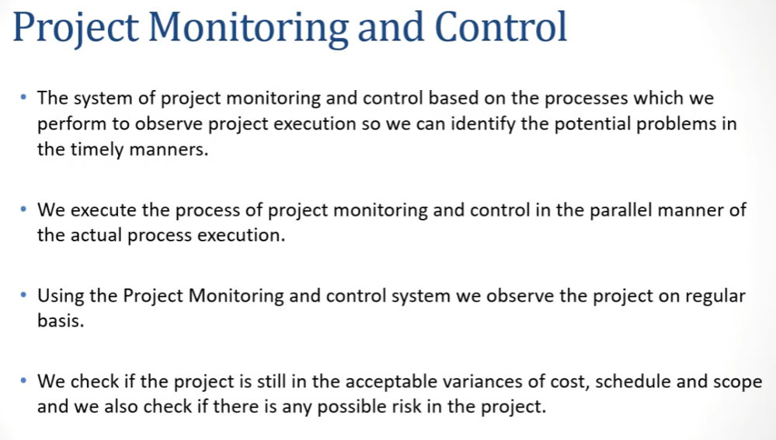

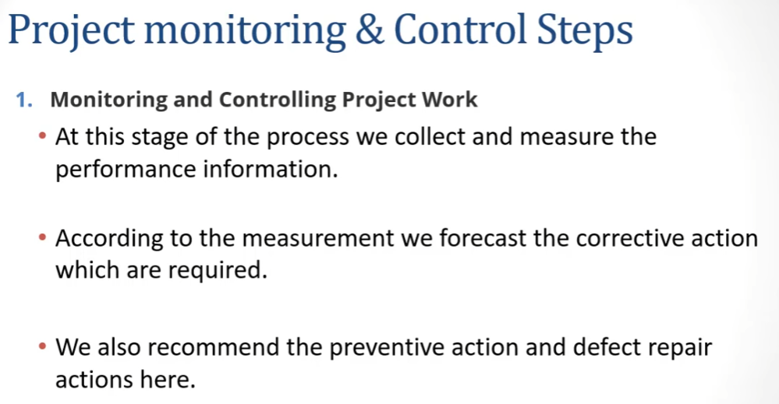

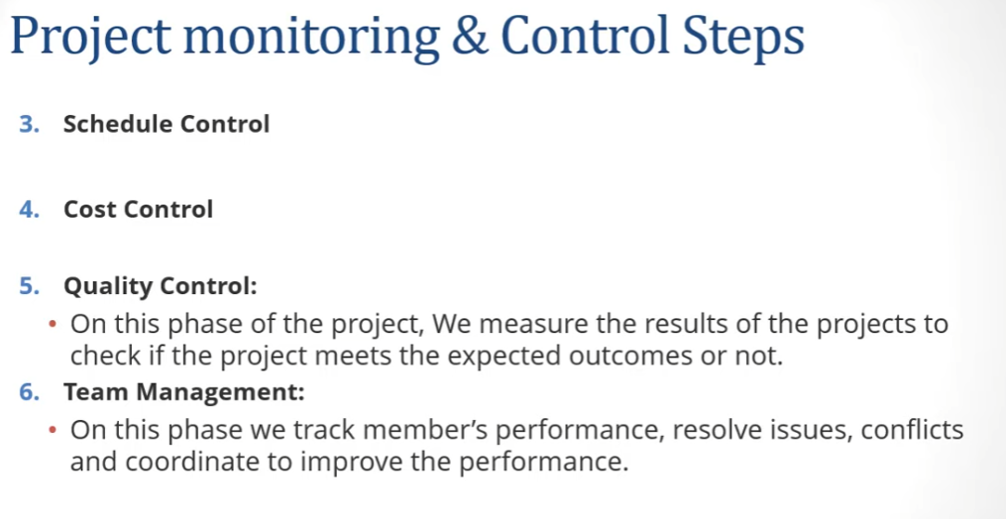

**Collecting Data**

Collecting Data is a technique to collect data from different – different stages by manager to make a best decision for project.

Collecting data is an essential aspect of project monitoring and control in software project management. It allows project managers to track progress, identify potential issues, and make informed decisions to keep the project on track.

Here are some key considerations for collecting data in project monitoring and control:

Determine what data to collect: Start by identifying the key metrics and indicators that will help you monitor project progress. These might include items such as project milestones, task completion rates, budget tracking, defect rates, and customer satisfaction metrics.

Choose the right tools: There are many tools available for collecting and tracking project data, including spreadsheets, project management software, and specialized monitoring and control tools. Choose the tools that best suit your needs and that can integrate with other project management tools used by your team.

Establish data collection processes: Develop clear and consistent processes for collecting data, including who is responsible for collecting and entering data, how often data will be collected, and how data will be stored and shared with stakeholders.

Ensure data accuracy and completeness: It's important to ensure that the data you collect is accurate, complete, and up-to-date. This requires ongoing monitoring and validation of data sources, as well as data quality checks to identify and correct any errors or inconsistencies.

Use data to inform decision-making: Once you have collected and analyzed project data, use it to inform decision-making and adjust project plans as needed. This might involve making changes to project timelines, resource allocation, or project scope based on the insights you gain from the data.

Overall, collecting data is a critical component of project monitoring and control in software project management. By establishing clear processes, using the right tools, and analyzing data to inform decision-making, project managers can keep their projects on track and ensure successful outcomes.

**visualizing progress /Data Visualizing**

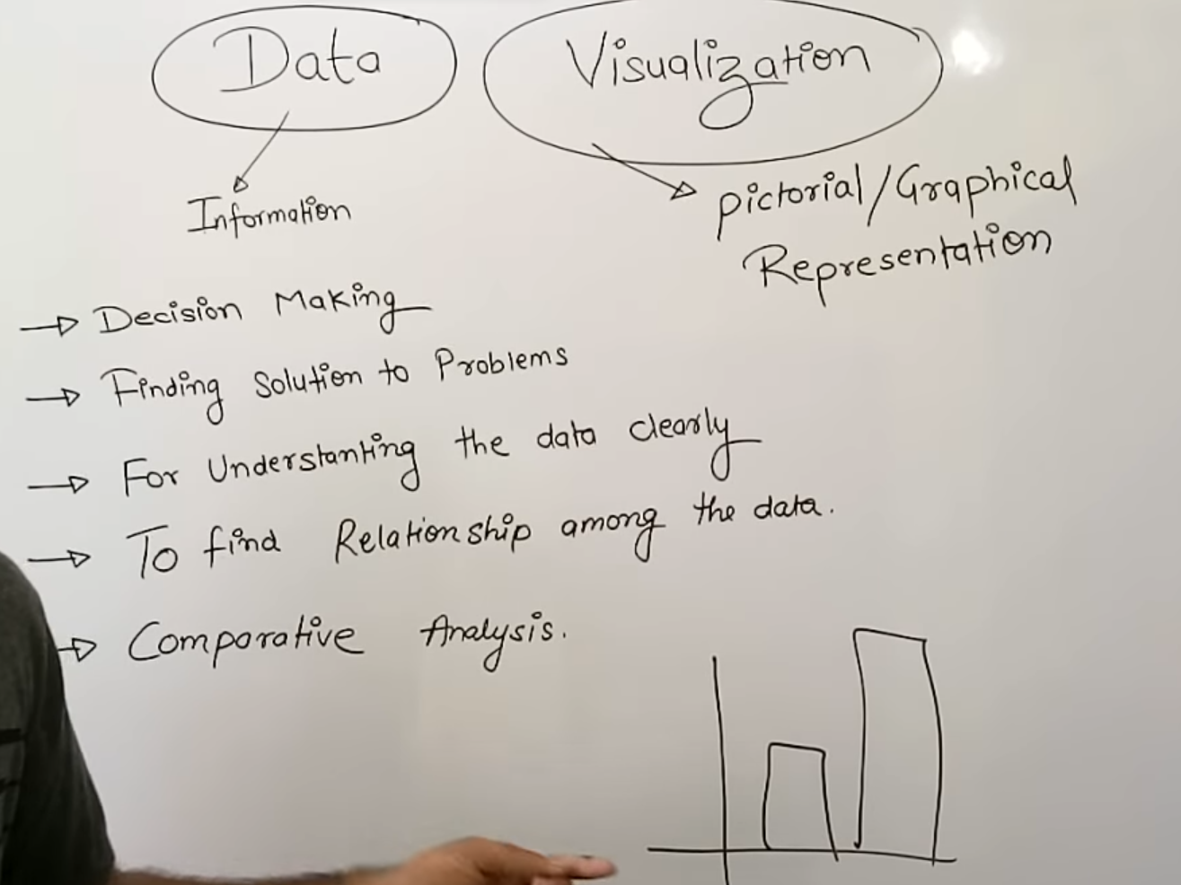

Visualizing progress in software project management is an essential task that helps teams to stay on track, identify issues, and communicate progress to stakeholders. Here are some ways to visualize progress in software project management:

Gantt Charts: Gantt charts are a popular tool used to visualize project timelines and tasks. They show the start and end dates of each task and provide an overview of how long each task will take. This makes it easy to identify delays or dependencies that may impact the project's progress.

Burndown Charts: Burndown charts are used to track the progress of tasks over time. They show how much work remains to be completed and how much time is left before the project's deadline. This helps teams to identify if they are falling behind schedule and adjust their plans accordingly.

Kanban Boards: Kanban boards are a visual way to manage tasks and workflows. They provide an overview of all the tasks that need to be completed and their current status. This makes it easy to see which tasks are on track, which are delayed, and which need urgent attention.

Dashboards: Dashboards are used to provide an overview of project performance. They typically include metrics such as project status, completion percentage, and key performance indicators (KPIs). This makes it easy for stakeholders to track project progress and identify areas that need attention.

Agile Charts: Agile charts, such as velocity charts, cumulative flow diagrams, and cycle time charts, are used to track the progress of agile projects. They provide an overview of how quickly tasks are being completed, how much work is in progress, and how much work remains to be done. This helps teams to identify bottlenecks and optimize their workflow.

In summary, there are many ways to visualize progress in software project management. The key is to use a tool that works for your team's workflow and helps you identify issues and adjust your plans accordingly.

**Cost Monitoring**

Cost monitoring is a crucial aspect of software project management. It involves tracking the project's expenses and making sure they stay within the allocated budget. Here are some key steps involved in cost monitoring for software projects:

Develop a budget: Before starting a software project, it's important to develop a detailed budget that outlines all of the expected expenses. This budget should take into account the cost of software development tools, hardware, personnel, training, and any other expenses that may arise during the project.

Track expenses: Once the project is underway, it's important to track all expenses closely. This can be done using various software tools, such as spreadsheets or project management software. Make sure to record all expenses in real-time and keep accurate records of all transactions.

Review and analyze expenses: Regularly review and analyze the project's expenses to ensure they are staying within the allocated budget. If any unexpected expenses arise, adjust the budget accordingly and update the cost tracking system.

Communicate with stakeholders: Keep all stakeholders informed of the project's cost status. Provide regular updates on expenses and any changes to the budget. This will help to build trust and maintain transparency with all stakeholders.

Implement cost-saving measures: Look for opportunities to reduce costs without sacrificing project quality. For example, you might consider using open-source software or outsourcing certain tasks to a lower-cost provider.

By closely monitoring project costs and taking steps to reduce expenses where possible, you can ensure that your software project stays within budget and meets its objectives.

**Review Techniques**

Software project management involves a wide range of activities, including planning, tracking, monitoring, and controlling software development projects. Reviews are an essential part of software project management, and they play a crucial role in ensuring the quality of software products. Here are some of the commonly used review techniques in software project management:

Code Reviews: Code reviews involve examining source code to identify defects, potential security issues, and improve the overall quality of the code. Code reviews can be performed manually or using automated tools. Manual code reviews involve human experts examining code, whereas automated code reviews are performed using tools that analyze code for known issues.

Design Reviews: Design reviews are conducted to evaluate the architecture and design of software applications. The goal of design reviews is to ensure that the software design meets the requirements and specifications of the project.

Requirements Reviews: Requirements reviews are conducted to ensure that the requirements for the software project are complete, correct, and consistent. Requirements reviews can be performed manually or using automated tools.

Test Reviews: Test reviews are conducted to evaluate the testing process and ensure that it is adequate to validate the software product's functionality. Test reviews can also be used to identify areas for improvement in the testing process.

Inspection: Inspection is a formal review process that involves a team of reviewers examining a software product to identify defects and improve its overall quality. Inspection can be used for any software artifact, including code, design, and requirements.

Walkthrough: Walkthroughs are informal review sessions that involve a team of stakeholders reviewing a software product to provide feedback. Walkthroughs can be used to review any software artifact, and they are typically less structured than inspections.

Pair Programming: Pair programming involves two developers working together on a single code base. One developer writes the code, while the other reviews it in real-time. Pair programming can help identify defects and improve code quality while also facilitating knowledge sharing between team members.

In conclusion, software project management involves a wide range of review techniques to ensure the quality of software products. Each technique has its strengths and weaknesses, and software project managers must choose the most appropriate technique based on the project's needs and objectives.

**Project Termination Review**

project termination review in software project management?

Project Termination Review, also known as post-project evaluation or project post-mortem, is a process in software project management that takes place after the project is completed or terminated. Its purpose is to review the project's performance and results, assess what went well and what didn't, and identify areas for improvement.

The following are some of the key components of a project termination review:

Goals and Objectives: The first step is to review the project's goals and objectives. This includes assessing whether the project was successful in achieving its intended outcomes and identifying any gaps between the original goals and the final results.

Deliverables and Milestones: The next step is to review the project's deliverables and milestones. This includes assessing whether all the deliverables were completed on time and within budget, and whether the milestones were achieved as planned.

Stakeholder Satisfaction: The project termination review should also assess the satisfaction levels of the stakeholders, including customers, sponsors, and project team members. This includes gathering feedback on the quality of the deliverables, communication, and project management practices.

Lessons Learned: The review should identify lessons learned from the project, including best practices and areas for improvement. This includes analysing the root causes of any issues or problems that arose during the project, and identifying ways to prevent them in future projects.

Documentation: The project termination review should document all the findings, recommendations, and lessons learned in a report. This report should be shared with all stakeholders, including the project team, sponsors, and customers.

Overall, the project termination review is an important process in software project management that helps to ensure continuous improvement and success in future projects.

**Earned value analysis (EVA)**

Earned value analysis (EVA) is a technique used in project management to measure the progress and performance of a project. EVA is particularly useful for software project management because it can help project managers to track and manage the progress of complex software development projects.

In EVA, the project manager measures the progress of a project by comparing the actual costs and work completed to the planned costs and work that should have been completed by a certain point in time. This information is then used to calculate the project's "earned value," which is an estimate of the value of the work that has been completed.

EVA can be used to calculate several key performance indicators (KPIs) for a software project, including:

Cost Variance (CV): The difference between the actual costs and the planned costs.

Schedule Variance (SV): The difference between the earned value and the planned value.

Cost Performance Index (CPI): The ratio of the earned value to the actual costs.

Schedule Performance Index (SPI): The ratio of the earned value to the planned value.

By tracking these KPIs, project managers can identify potential problems and take corrective action before they become major issues. For example, if the cost variance is negative, it may indicate that the project is over budget and that the project manager needs to take action to bring costs under control.

EVA can also help project managers to forecast the final cost and completion date of a software project based on the current performance metrics. This can be useful for making decisions about resource allocation, schedule changes, and project scope.

Overall, EVA is a powerful tool for software project managers, providing them with valuable insights into the performance of their projects and helping them to make informed decisions about project management.

**Change control**

Change control is an important aspect of software project management that involves managing and controlling changes to the project scope, schedule, cost, or quality. It ensures that any changes made to the project are controlled, documented, and approved, so that they do not negatively impact the project objectives or outcomes.

The following are some of the key steps involved in change control in software project management:

Identify the change: Any change to the project scope, schedule, cost, or quality should be identified and documented.

Assess the impact: The impact of the change on the project objectives, timeline, budget, resources, and stakeholders should be assessed.

Evaluate the alternatives: Alternative solutions to the change should be evaluated, and the best option should be selected based on the impact analysis.

Develop a change request: A change request should be developed, which includes the proposed change, the reason for the change, the impact analysis, and the alternative solutions.

Review and approve: The change request should be reviewed by the project stakeholders, and approved or rejected based on the impact analysis and alternative solutions.

Implement the change: If the change request is approved, the change should be implemented and documented.

Monitor and control: The impact of the change on the project should be monitored and controlled, and any further changes should be managed through the change control process.

Overall, effective change control is essential to the success of software projects, as it ensures that any changes made to the project are managed in a controlled and documented way, to minimize the risk of negative impacts on the project objectives or outcomes.

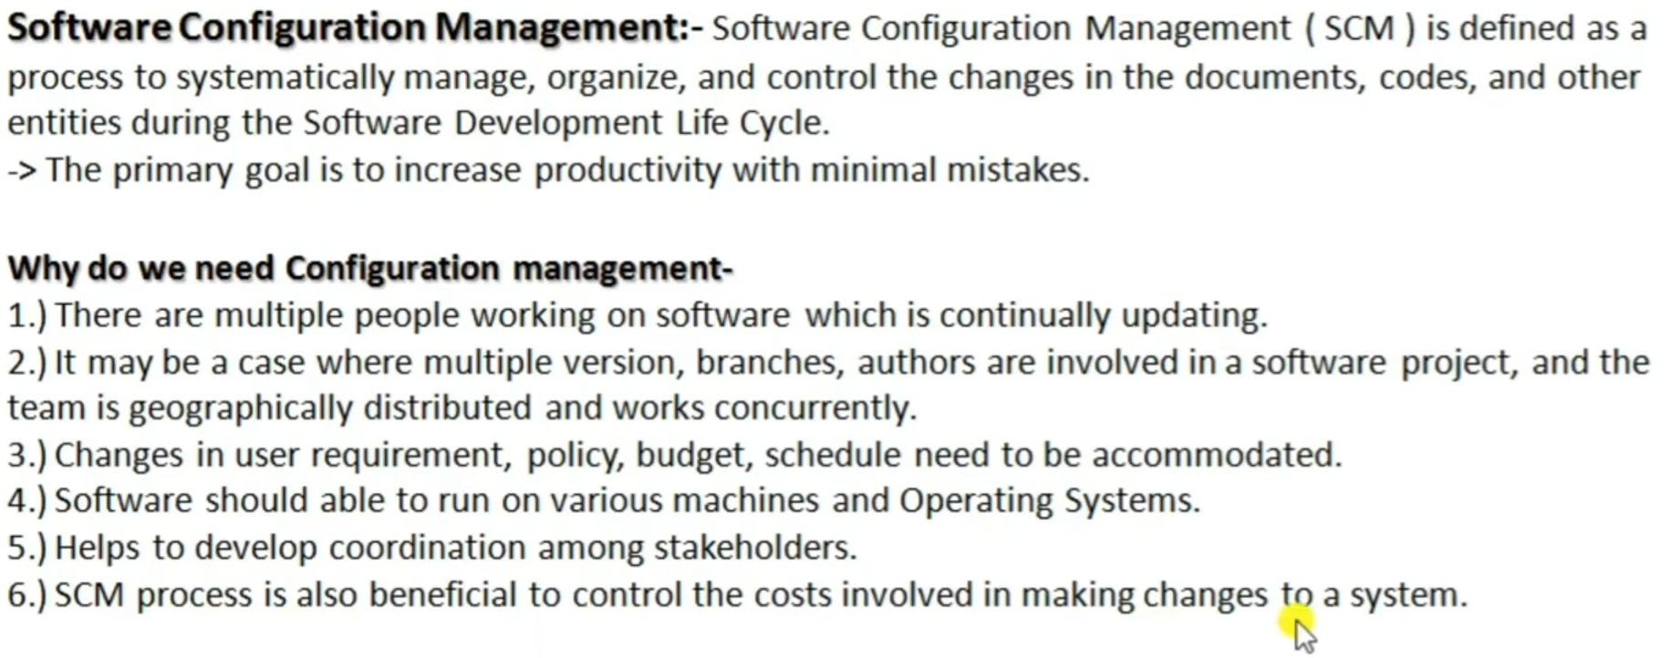**Software Configuration Management ( SCM )**

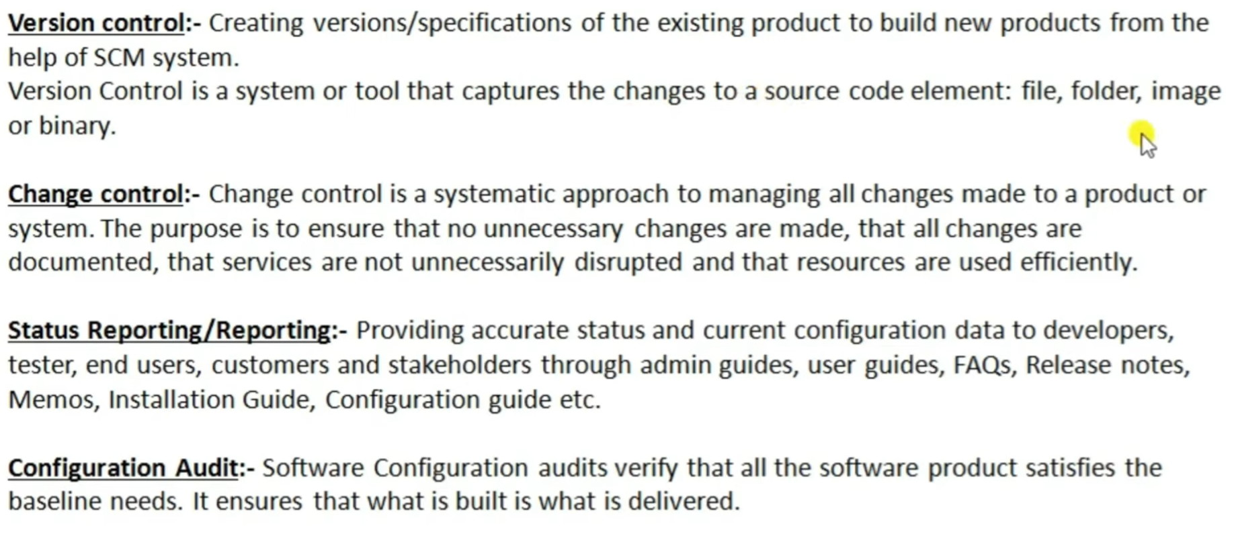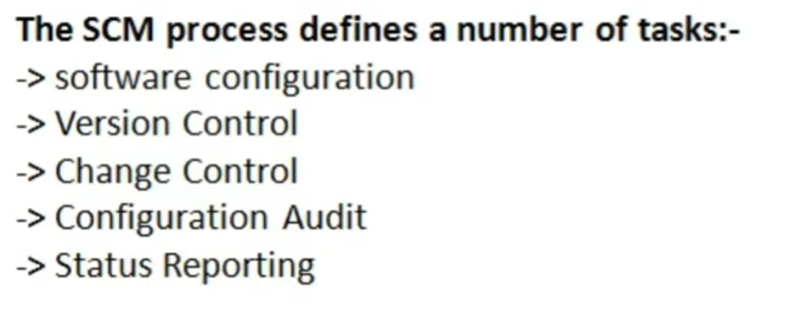

**Managing contracts**

Managing contracts is an essential aspect of software project management. Contracts are legal agreements that define the terms and conditions of a project, including the scope of work, timelines, budget, and payment schedules. Effective contract management ensures that all parties involved in a project are aware of their responsibilities and obligations, and that the project is completed successfully.

Here are some key considerations for managing contracts in software project management:

Clearly define the scope of work: Before drafting a contract, it's essential to have a clear understanding of the project's scope, objectives, and deliverables. This will help ensure that the contract accurately reflects the project's requirements and avoids any misunderstandings or disputes down the line.

Establish timelines and milestones: A well-written contract should include specific timelines and milestones for the project, including deadlines for deliverables and payment schedules. This will help keep the project on track and ensure that all parties are aware of the project's progress.

Identify risks and contingencies: Software projects can be complex, and unexpected issues can arise. Contracts should include provisions for managing risks and contingencies, such as changes in requirements, project delays, or unexpected costs.

Include clear termination clauses: Termination clauses are important in case a project needs to be terminated early due to unforeseen circumstances. Clear termination clauses will help ensure that all parties are aware of their rights and obligations in case of project termination.

Ensure contract compliance: Once a contract is signed, it's essential to ensure that all parties comply with the terms and conditions. This may involve monitoring project progress, tracking expenditures, and ensuring that all deliverables are completed on time and to the required standard.

In summary, effective contract management is essential for successful software project management. By clearly defining the scope of work, establishing timelines and milestones, identifying risks and contingencies, including clear termination clauses, and ensuring contract compliance, software projects can be completed successfully and within budget.

**Types Of Contracts**

There are several types of contracts commonly used in software project management. Here are a few examples:

Fixed-price contract: This is a contract where the project cost is fixed and agreed upon at the beginning of the project. The vendor is responsible for completing the project within the budget. This type of contract is useful when the project requirements are well-defined and there is little risk of changes to the scope.

Time and materials contract: This is a contract where the client pays for the time and materials used in the project. This type of contract is useful when the project requirements are not well-defined or when the scope of the project is likely to change.

Cost-plus contract: This is a contract where the vendor is paid for the cost of the project plus a fixed percentage as profit. This type of contract is useful when the project requirements are uncertain and the risk of changes to the scope is high.

Performance-based contract: This is a contract where the vendor is paid based on the performance of the project. This type of contract is useful when the project has clear performance metrics that can be measured.

Maintenance contract: This is a contract where the vendor is responsible for providing ongoing maintenance and support for the software after it has been delivered. This type of contract is useful when the software is expected to require ongoing updates and support.

It is important to choose the right type of contract for each project to ensure that both parties are satisfied with the outcome.

**Stages In Contract Placement**

In software project management, the stages in contract placement can vary depending on the specific project and its requirements. However, some common stages involved in contract placement for software projects are:

Needs Assessment: The first stage is to assess the needs and requirements of the project. This includes understanding the project scope, objectives, timelines, budget, and other essential factors that impact the project's success.

Request for Proposal (RFP): Once the project requirements are defined, an RFP is created and issued to potential vendors who can provide software development services. The RFP contains detailed information about the project's scope, objectives, timelines, budget, and evaluation criteria.

Vendor Selection: After receiving proposals from vendors, the project team evaluates them based on their technical expertise, experience, project approach, price, and other relevant factors. The project team selects the vendor that best fits the project's requirements.

Contract Negotiation: Once the vendor is selected, the project team negotiates the contract terms, including the scope of work, project timeline, payment terms, intellectual property rights, confidentiality agreements, and other relevant terms and conditions.

Contract Execution: Once the contract is finalized and signed by both parties, the vendor begins working on the project according to the agreed-upon terms and conditions.

Contract Monitoring and Management: Throughout the project, the project team monitors the vendor's progress and performance to ensure that the project is progressing according to the contract terms. If there are any issues or delays, the project team works with the vendor to resolve them and keep the project on track.

Contract Closure: Once the project is completed, the contract is closed, and the vendor is paid according to the agreed-upon payment terms. The project team also evaluates the vendor's performance and delivers feedback to help improve future project outcomes.

**Typical Term Of a Contract**

The typical term or duration of a contract in software project management can vary depending on several factors such as the scope of the project, complexity, size of the team, and the overall timeline for completion. However, a common term for a software project management contract is between 6 months to 2 years.

It's important to note that the duration of the contract may also depend on the type of contract being used. For example, a fixed-price contract may have a shorter term compared to a time and materials contract, which can be extended as the project progresses.

Ultimately, the term of the contract should be discussed and agreed upon between the parties involved in the project, taking into account all relevant factors and potential risks.

**Contract Management And Acceptance**

Contract management and acceptance are both important aspects of software project management. Here's a brief overview of each:

**Contract Management:**

In software project management, a contract is typically drawn up between the customer (or client) and the development team (or vendor). The contract outlines the terms of the project, including the scope of work, timeline, budget, deliverables, and any other relevant details. It's important to manage the contract effectively to ensure that both parties are aware of their responsibilities and that the project runs smoothly.

Some key considerations for contract management in software project management include:

Ensuring that the contract is legally binding and enforceable

Clearly defining the scope of work and deliverables

Establishing a timeline and milestones for the project

Identifying and managing risks and contingencies

Managing any changes to the project scope or timeline

Establishing a payment schedule and ensuring that payments are made on time

Ensuring that all parties comply with the terms of the contract

**Acceptance:**

Acceptance is the process of verifying that the software meets the requirements specified in the contract. This involves testing the software to ensure that it functions as expected and meets the client's needs. The acceptance process typically involves several stages, including:

Unit testing: testing individual components of the software to ensure that they function correctly

Integration testing: testing how the components work together as a whole

System testing: testing the software in a simulated environment to ensure that it meets the requirements specified in the contract

User acceptance testing: testing the software with real users to ensure that it is easy to use and meets their needs

The acceptance process is important because it ensures that the software meets the client's expectations and is fit for purpose. If any issues are identified during the acceptance process, they can be addressed before the software is released to the client.

**UNIT - 5**

## Quality Management?

Software Quality Management ensures that the required level of quality is achieved by submitting improvements to the product development process. SQA aims to develop a culture within the team and it is seen as everyone's responsibility.

Software Quality management should be independent of project management to ensure independence of cost and schedule adherences. It directly affects the process quality and indirectly affects the product quality.

## Activities of Software Quality Management:

* **Quality Assurance -**QA aims at developing Organizational procedures and standards for quality at Organizational level.
* **Quality Planning -**Select applicable procedures and standards for a particular project and modify as required to develop a quality plan.
* **Quality Control -**Ensure that best practices and standards are followed by the software development team to produce quality products.

**People Management**

**People management is an essential part of software project management as it involves leading, motivating, and guiding a team of software developers to ensure the successful completion of a project. Effective people management involves several key activities that are crucial to the success of a software project.**

**Team Building: Building a cohesive team is essential to the success of any software project. As a software project manager, you need to foster a collaborative and supportive team environment by ensuring that team members have a clear understanding of their roles, responsibilities, and project goals.**

**Communication: Effective communication is critical in software project management. You need to communicate project goals, progress, and any changes to team members in a clear and concise manner. Regular communication can help ensure that everyone is on the same page and working towards the same objectives.**

**Motivation: As a software project manager, you need to motivate team members to achieve their best work. This involves recognizing their achievements, providing constructive feedback, and creating a positive work environment.**

**Performance Management: Performance management involves assessing the performance of team members and providing feedback to help them improve. This can involve setting performance goals, monitoring progress, and providing regular feedback.**

**Conflict Management: Conflict can arise in any team, and it is essential to have a process in place to manage it effectively. As a software project manager, you need to be able to identify and resolve conflicts in a constructive manner.**

**Overall, effective people management is critical to the success of any software project. By building a strong team, communicating effectively, motivating team members, managing performance, and resolving conflicts, you can help ensure that your software project is completed successfully.**

**Understanding Behevior**

**Behavior in quality and people management is critical in software project management because successful projects depend heavily on the behavior of the people involved. In this context, quality management refers to the processes and activities involved in ensuring that the project outputs meet the desired standards and requirements, while people management refers to the processes and activities involved in managing the individuals and teams working on the project.**

**To understand behavior in quality management, it is essential to recognize that it is not enough to simply have processes in place; the individuals responsible for carrying out those processes must also have the right mindset and behavior. This means that they need to have a strong focus on quality, attention to detail, and a commitment to continuous improvement. Leaders can encourage this behavior by setting clear expectations, providing adequate training and resources, and recognizing and rewarding those who consistently demonstrate the desired behavior.**

**Similarly, in people management, understanding behavior is critical for ensuring that teams work effectively and efficiently. Effective people management involves understanding the unique strengths and weaknesses of each team member, communicating clearly, providing feedback, and fostering a culture of collaboration and continuous learning. Managers who are able to recognize and address behavioral issues in their teams can help create a positive work environment that encourages motivation, productivity, and creativity.**

**Overall, successful software project management requires a deep understanding of both quality and people management, including how behavior affects both areas. By prioritizing the right behaviors, setting clear expectations, providing support, and fostering a positive work environment, project managers can create a culture of success that leads to high-quality outputs and satisfied stakeholders.**

**Organizational Behavior**

**Organizational behavior is a critical aspect of software project management as it involves understanding the behavior of people within an organization and how they interact with each other to achieve common goals. Quality and people management are also important considerations in software project management.**

**In terms of quality management, the software development process must be designed to ensure that the final product meets the required quality standards. This involves the use of quality assurance techniques such as testing, inspection, and validation. Quality control measures must also be put in place to ensure that the software is delivered on time, within budget, and to the required level of quality.**

**People management in software project management involves managing the team responsible for delivering the software project. This involves recruiting, training, and managing the team members. Effective people management involves understanding the strengths and weaknesses of each team member and leveraging these strengths to achieve the project goals. It also involves effective communication, delegation, and conflict resolution skills to ensure that the team works together efficiently and effectively.**

**To ensure that quality and people management are effectively integrated into software project management, project managers must create a culture that values these aspects of project management. This involves setting clear expectations for quality and people management, creating a supportive and collaborative team environment, and implementing effective processes and procedures for managing quality and people issues.**

**Selecting The Right Person For A Job**

**Selecting the right person for a job is a crucial decision that can have a significant impact on an organization's success. Here are some steps you can follow to help you select the right person for the job:**

**Determine the job requirements: Before you start the recruitment process, it's essential to determine the skills, qualifications, and experience required for the job. This will help you identify the ideal candidate for the role.**

**Advertise the job: Use job boards, social media, and other recruitment channels to advertise the job vacancy. This will attract a pool of candidates with different backgrounds and experiences.**

**Screen the resumes: Once you receive the applications, review them carefully to ensure that the candidates meet the job requirements. Shortlist the most qualified candidates for further assessment.**

**Conduct interviews: Interview the shortlisted candidates to evaluate their communication skills, problem-solving abilities, and other relevant skills required for the job. Ask open-ended questions to learn more about the candidate's experience, goals, and work style.**

**Check references: Verify the candidate's employment history and reach out to their references to get a better understanding of their work ethic and performance.**

**Assess cultural fit: Consider the candidate's personality and work style to ensure that they will fit in with the company culture and work well with the existing team.**

**Make the job offer: Once you have identified the right candidate, make them a job offer that includes details such as salary, benefits, and start date.**

**By following these steps, you can increase the chances of selecting the right person for the job and making a successful hire.**

**Motivation**

**Motivation plays an important role in quality management as it can impact the overall effectiveness of a quality management system. Here are some ways motivation can contribute to quality management:**

**Employee engagement: Motivated employees are more likely to be engaged in their work, which can lead to a higher level of quality. When employees feel valued and invested in their work, they are more likely to take ownership of their tasks and strive to do their best.**

**Continuous improvement: Motivated employees are more likely to seek out ways to improve processes and systems. This can lead to a culture of continuous improvement, where employees are constantly looking for ways to make the quality management system better.**

**Customer satisfaction: Motivated employees are more likely to provide excellent customer service, which can lead to higher levels of customer satisfaction. When employees are motivated to provide high-quality products and services, they are more likely to meet or exceed customer expectations.**

**Problem-solving: Motivated employees are more likely to approach problems with a positive attitude and a willingness to find solutions. This can lead to more effective problem-solving and a faster resolution of issues.**

**Overall, motivation is an important factor in quality management, as it can impact the effectiveness of the quality management system and the overall success of the organization.**

**Hackman and Oldham’s Job Characteristics Model**

Hackman and Oldham’s Job Characteristics Model, also called The Job Characteristics Theory (JCT) and Core Characteristics Model, was created in the 1970s and is one of the key models of employee motivation at work. This model focuses on looking closer into the individual task design included in the job role rather than the job as a whole. Hackman and Oldham believe that the implementation of core job characteristics in [job design](https://app.studysmarter.de/link-to?studyset=3784076&summary=25195339&language=en&amp_device_id=-jyK7ZOjfbnWmE1jc7EKvP) will increase employees’ work satisfaction.

The **Hackman and Oldham job characteristics model** is made up of five key elements that are believed to influence employees’ satisfaction at work. The five elements of the model that can increase or decrease employee satisfaction are:

* Skill variety,
* Task identity,
* Task significance,
* Autonomy, and
* Feedback.

## Five Elements of Hackman and Oldham’s Model

Let's look at these elements in more detail. The five elements are:

* **Skill variety -**Jobs should be designed in the way that they require a variety of skills and talents from employees to be performed. As that will make jobs more interesting and less repetitive.
* **Task Identity-** Organisations should incorporate tasks that have clearly defined start and finish meaning that employees will be aware of when the task is completed. Employees’ job satisfaction may increase as they will be able to see the outcomes of the completed tasks.
* **Task significance -**Task must be significant, task should matter and have a meaning to the company or the society.
* **Autonomy -**This is the level of freedom for employees to choose a method and time of how and when to complete a task. Hackman and Oldham believed that jobs that are made more flexible bring greater satisfaction for employees.
* **Feedback -** Employees should have access to sufficient feedback regarding their performances. As that will assist them in knowing what areas they need to improve on.

These five elements are positively related to job satisfaction as once incorporated into the [job design](https://app.studysmarter.de/link-to?studyset=3784076&summary=25195339&language=en&amp_device_id=-jyK7ZOjfbnWmE1jc7EKvP) they result in employees experiencing positive psychological states.

<https://youtu.be/kkld2WMZnD8> : - Video link of **Hackman and Oldham job characteristics model**

**Working In A Group**

Working in a group can be a very effective way to achieve a common goal, share responsibilities, and leverage the skills and strengths of individual members. However, it can also be challenging and requires effective communication, collaboration, and coordination to ensure that everyone is on the same page and working towards the same objective.

Here are some tips for working effectively in a group:

Clearly define the goals and objectives of the group and make sure that everyone understands them.

Establish clear roles and responsibilities for each member of the group to ensure that everyone knows what is expected of them.

Foster open and honest communication among all members of the group to ensure that everyone is informed and that there are no misunderstandings.

Encourage active participation from all members of the group and ensure that everyone has a chance to contribute their ideas and expertise.

Establish a schedule for regular meetings and check-ins to ensure that everyone is making progress towards the goal and that any issues or concerns can be addressed in a timely manner.

Be flexible and willing to adapt to changes in the group's goals or approach as needed.

Celebrate successes and milestones along the way to keep the group motivated and engaged.

Remember, working in a group can be challenging, but with the right approach, it can also be incredibly rewarding and lead to great results.

**Organization Structure**

Organizational structure in software project management refers to the way in which tasks and responsibilities are allocated among individuals or groups within the project team. There are several common organizational structures that are used in software project management:

Functional structure: In this structure, the team members are grouped by their function or expertise, such as developers, testers, and designers. Each member reports to a functional manager, and the project manager coordinates the work among the various functional groups.

Project-based structure: In this structure, the team is formed for a specific project and is disbanded after the project is complete. The team members report directly to the project manager, who is responsible for the project's success.

Matrix structure: This structure is a combination of the functional and project-based structures. In this structure, team members are assigned to a functional group and also work on a project under the direction of a project manager.

Product-based structure: In this structure, the team members are organized around a particular product or product line. Each team member has specific responsibilities related to that product, and the project manager oversees the work of the team.

**Team Organization**

There are many ways to organize the project team. Some important ways are as follows :

Hierarchical team organization

Chief-programmer team organization

Matrix team, organization

Egoless team organization

Democratic team organization

**Hierarchical team organization :**

In this, the people of organization at different levels following a tree structure. People at bottom level generally possess most detailed knowledge about the system. People at higher levels have broader appreciation of the whole project.

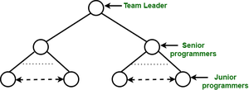

**Chief -programmer team organization :**

**Chief-programmer team organization :**

This team organization is composed of a small team consisting the following team members :

The Chief programmer : It is the person who is actively involved in the planning, specification and design process and ideally in the implementation process as well.

The project assistant : It is the closest technical co-worker of the chief programmer.

The project secretary : It relieves the chief programmer and all other programmers of administration tools.

Specialists : These people select the implementation language, implement individual system components and employ software tools and carry out tasks.

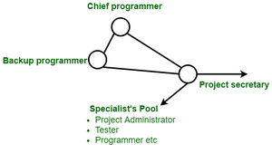

**Matrix Team Organization :**

In matrix team organization, people are divided into specialist groups. Each group has a manager.

**Democratic Team Organization :**

It is quite similar to the egoless team organization, but one member is the team leader with some responsibilities :

Coordination

Final decisions, when consensus cannot be reached.

**Decision making**

Decision making is a critical aspect of project management. Project managers are often required to make important decisions that can impact the success of a project. Effective decision making involves identifying the problem, gathering information, analyzing alternatives, and selecting the best course of action based on the project's goals, constraints, and available resources.

Project management involves planning, organizing, and controlling resources to achieve specific project goals within a defined timeframe. It requires a range of skills, including leadership, communication, risk management, and budgeting. Effective project management involves breaking down complex projects into manageable tasks, delegating responsibilities, and monitoring progress to ensure that the project is delivered on time, within budget, and to the desired quality standards.

In addition, project managers must be able to adapt to changes in project requirements, manage stakeholder expectations, and communicate effectively with team members, stakeholders, and clients. They must also be skilled at managing conflicts and resolving issues that arise during the project lifecycle. Overall, successful project management requires a combination of technical skills, interpersonal skills, and strategic thinking.

**Leadership**

**Leadership plays a critical role in project management. Effective leadership is essential to ensure that a project is delivered on time, within budget, and to the satisfaction of all stakeholders. Here are some of the key responsibilities of a leader in project management:**

**Setting the vision and goals: A leader in project management is responsible for defining the overall vision, goals, and objectives of the project. This involves establishing the scope of the project and defining what success looks like.**

**Building and managing the team: A leader must assemble a team of individuals with the necessary skills, knowledge, and experience to complete the project successfully. The leader is responsible for managing the team, providing guidance and support, and resolving conflicts as they arise.**

**Communicating effectively: A leader in project management must be an effective communicator. They need to keep stakeholders informed about project progress, provide updates on any changes, and manage expectations.**

**Managing resources: A leader must ensure that the project has the necessary resources, including budget, time, and equipment, to meet the project's goals.**

**Monitoring and controlling progress: A leader in project management is responsible for monitoring and controlling project progress. This involves tracking project milestones and identifying any potential risks or issues that could impact the project's success.**

**Making decisions: A leader in project management must make critical decisions throughout the project's lifecycle. This involves weighing options, assessing risks, and making timely decisions to keep the project on track.**

**In summary, effective leadership is essential for project management success. A leader must set the vision, build and manage the team, communicate effectively, manage resources, monitor progress, and make critical decisions to ensure project success.**

**Stress**

**Stress refers to a physiological and psychological response to a perceived threat or challenge. It is a natural response that helps us prepare to cope with situations that require action or adaptation. However, prolonged or chronic stress can have negative effects on our physical and mental health.**

**The stress response is triggered by the release of hormones such as cortisol and adrenaline, which prepare the body for a "fight or flight" response. This can lead to increased heart rate, blood pressure, and breathing rate, as well as muscle tension and heightened alertness.**

**Stress can be caused by a variety of factors, including work, relationships, financial difficulties, health problems, and major life changes. It can also be exacerbated by unhealthy coping mechanisms such as overeating, substance abuse, or social isolation.**

**Effective stress management techniques include regular exercise, relaxation techniques such as meditation or deep breathing, seeking social support, and seeking professional help if needed.**

**Health and Safety**

**Health and safety refers to the measures taken to protect the physical, mental, and social well-being of individuals in the workplace, public spaces, or other environments. It involves identifying and controlling potential hazards or risks that could cause harm or injury to people or damage to property.**

**In the workplace, health and safety measures may include providing protective equipment, ensuring proper training and supervision, implementing safety protocols, and maintaining a clean and safe environment. In public spaces, health and safety measures may include maintaining infrastructure, providing emergency services, and enforcing regulations to prevent accidents and injuries.**

**The goal of health and safety is to promote a safe and healthy environment for individuals to live, work, and interact in. This can help reduce the risk of accidents, injuries, and illnesses, and ultimately improve the quality of life for all.**

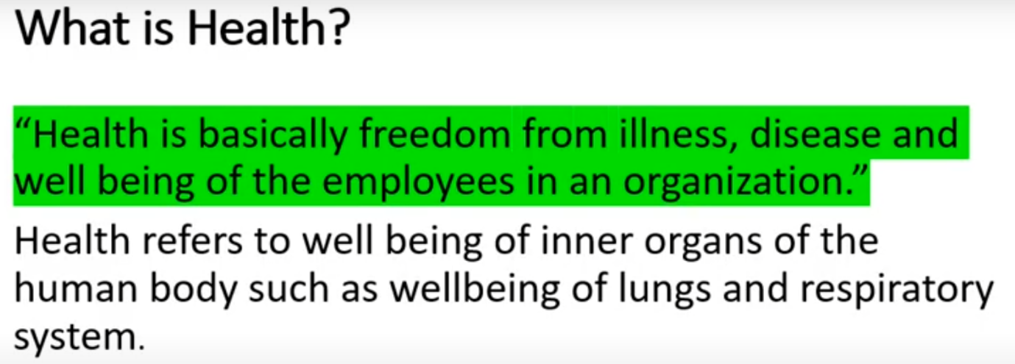

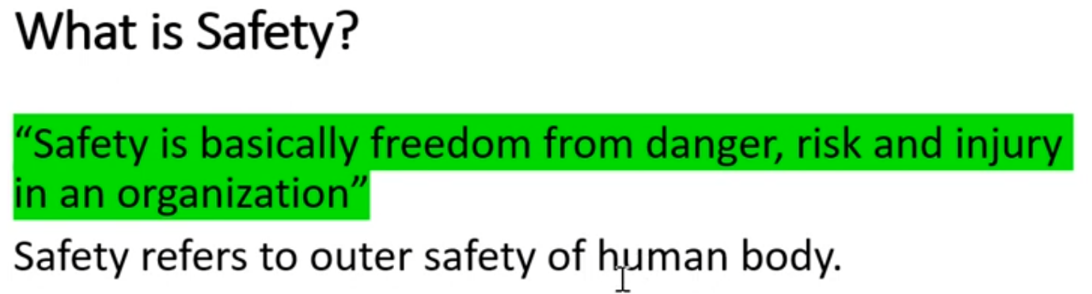

**ISO**

**(International Organization for Standardization)**

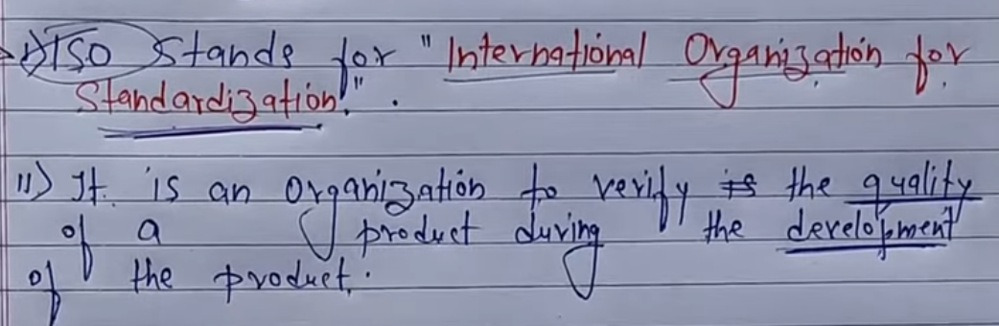

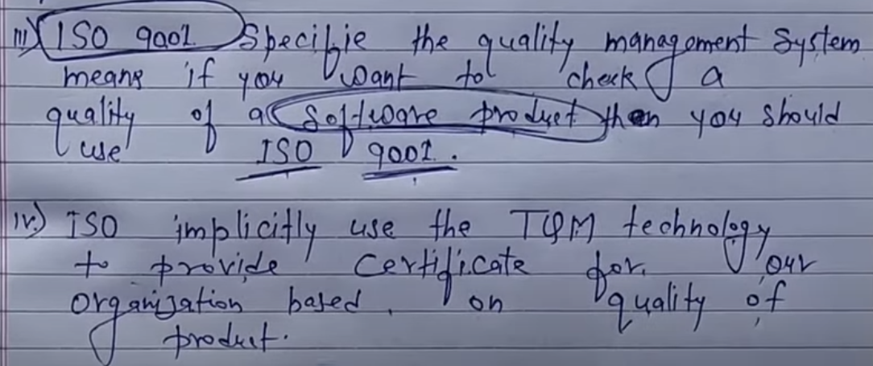

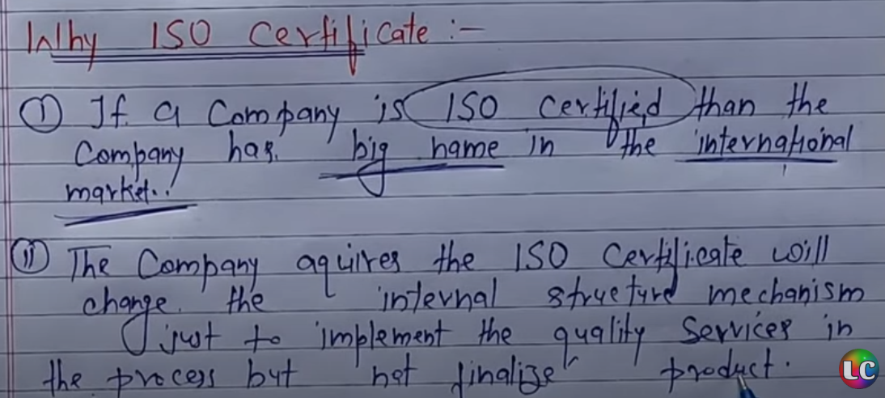

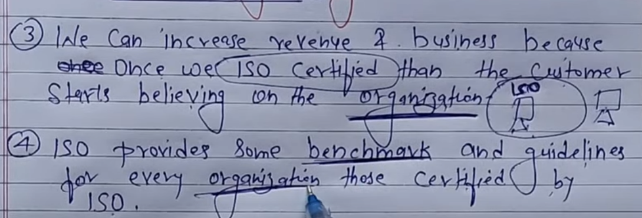



**Testing**

**Testing is an essential component of software project management. It helps to ensure that software is developed according to specifications, is free of defects, and meets user requirements. Testing also helps to reduce the risk of software failure in production and enhances the overall quality of the software.**

**Here are some key aspects of testing in software project management:**

**Test Planning: This involves developing a comprehensive test plan that defines the testing objectives, scope, test scenarios, test cases, and test environment. The plan should also include the testing schedule, resources required, and the criteria for measuring the success of the testing process.**

**Test Design: This involves developing test scenarios and test cases that cover all aspects of the software functionality and business requirements. The test cases should be designed to detect defects, validate the software behavior, and ensure that all user requirements are met.**

**Test Execution: This involves executing the test cases in the test environment and validating the results against the expected outcomes. The testing process should be thorough, repeatable, and include both manual and automated testing methods.**

**Defect Tracking and Reporting: This involves identifying defects, tracking them through the testing process, and reporting them to the development team for resolution. The defect tracking process should include metrics to measure the effectiveness of the testing process and to ensure that all defects are resolved in a timely manner.**

**Test Completion and Sign-off: This involves completing the testing process and obtaining sign-off from all stakeholders that the software is ready for production. The sign-off should be based on the testing results and should include a review of the test plan, test scenarios, and test cases.**

**In summary, testing is a critical component of software project management that helps to ensure that software is developed according to specifications, meets user requirements, and is of high quality. An effective testing process should include test planning, test design, test execution, defect tracking and reporting, and test completion and sign-off.**

**CMMI**

**CMMI, which stands for Capability Maturity Model Integration, is a process improvement model for software engineering and project management. The model was developed by the Software Engineering Institute (SEI) at Carnegie Mellon University and is widely used in the software industry.**

**The CMMI model consists of five maturity levels that represent an evolutionary path of continuous process improvement for software organizations. These maturity levels are:**

**Initial: In this level, processes are ad hoc and unstructured. There is little or no management of processes, and success depends on individual effort.**

**Managed: In this level, processes are planned, performed, measured, and controlled. The organization has established basic project management practices.**

**Defined: In this level, the organization has developed a set of standard processes that are documented, standardized, and integrated into the organization's standard process assets.**

**Quantitatively Managed: In this level, the organization focuses on quantitative management of the processes. The organization has established a quantitative understanding of the processes and uses data analysis to make decisions.**

**Optimizing: In this level, the organization focuses on continuous process improvement. The organization is proactive in identifying and implementing process improvements to enhance quality and increase productivity.**

**CMMI helps software organizations to identify areas where they can improve their processes, measure their progress, and achieve higher levels of maturity. It provides a framework for managing and improving software development processes, which leads to improved quality, increased productivity, and better customer satisfaction.**

# **Software Reliability**

Software Reliability means **Operational reliability**. It is described as the ability of a system or component to perform its required functions under static conditions for a specific period.

Software reliability is also defined as the probability that a software system fulfills its assigned task in a given environment for a predefined number of input cases, assuming that the hardware and the input are free of error.

Software Reliability is an essential connect of software quality, composed with functionality, usability, performance, serviceability, capability, installability, maintainability, and documentation. Software Reliability is hard to achieve because the complexity of software turn to be high. While any system with a high degree of complexity, containing software, will be hard to reach a certain level of reliability, system developers tend to push complexity into the software layer, with the speedy growth of system size and ease of doing so by upgrading the software.

**For example**, large next-generation aircraft will have over 1 million source lines of software on-board; next-generation air traffic control systems will contain between one and two million lines; the upcoming International Space Station will have over two million lines on-board and over 10 million lines of ground support software; several significant life-critical defense systems will have over 5 million source lines of software. While the complexity of software is inversely associated with software reliability, it is directly related to other vital factors in software quality, especially functionality, capability, etc.

## Test Automation?

Software Test automation makes use of specialized tools to control the execution of tests and compares the actual results against the expected result. Usually, regression tests, which are repetitive actions, are automated.

Testing Tools not only helps us to perform regression tests but also helps us to automate data set up generation, product installation, GUI interaction, defect logging, etc. Automation tools are used for both Functional and Non-Functional testing.

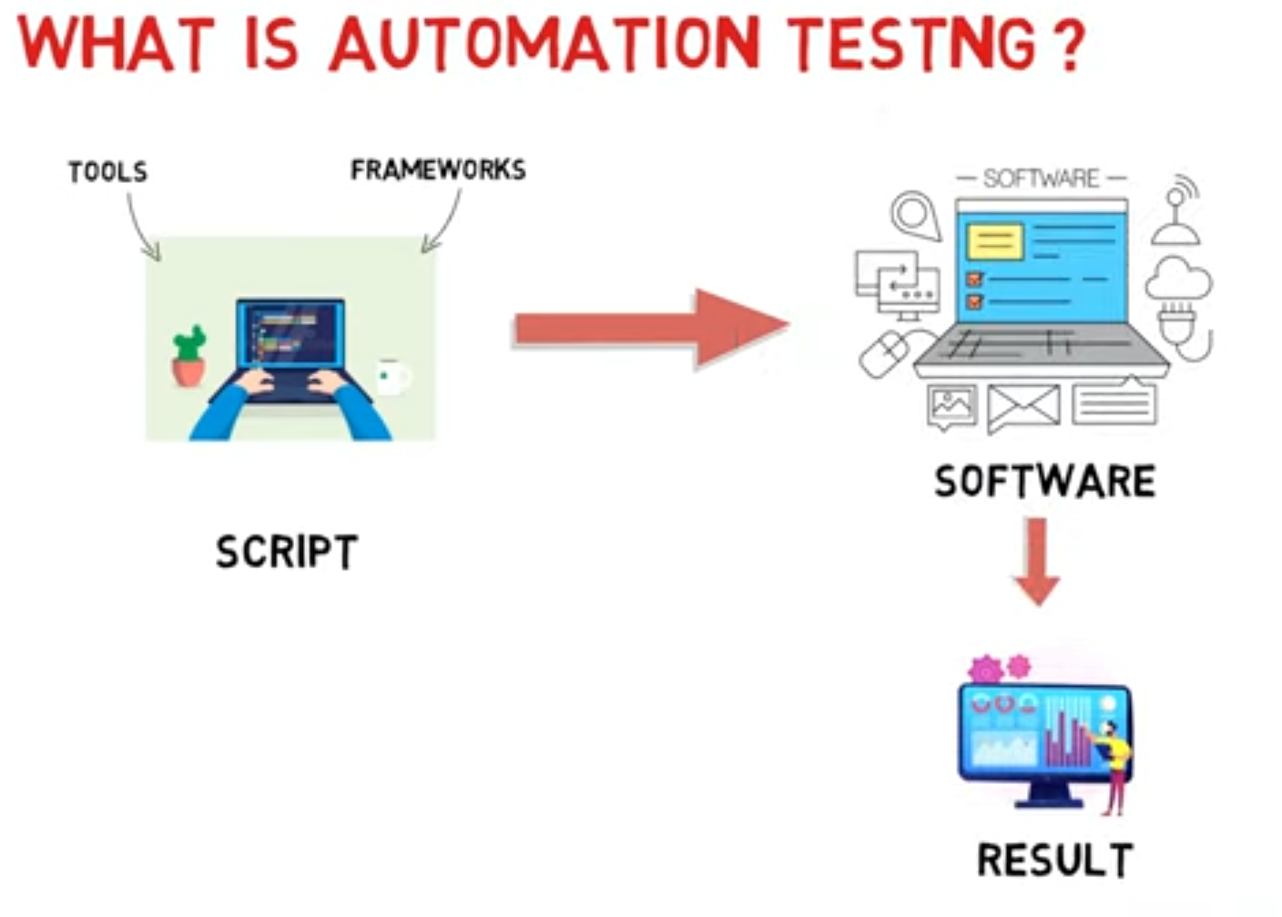

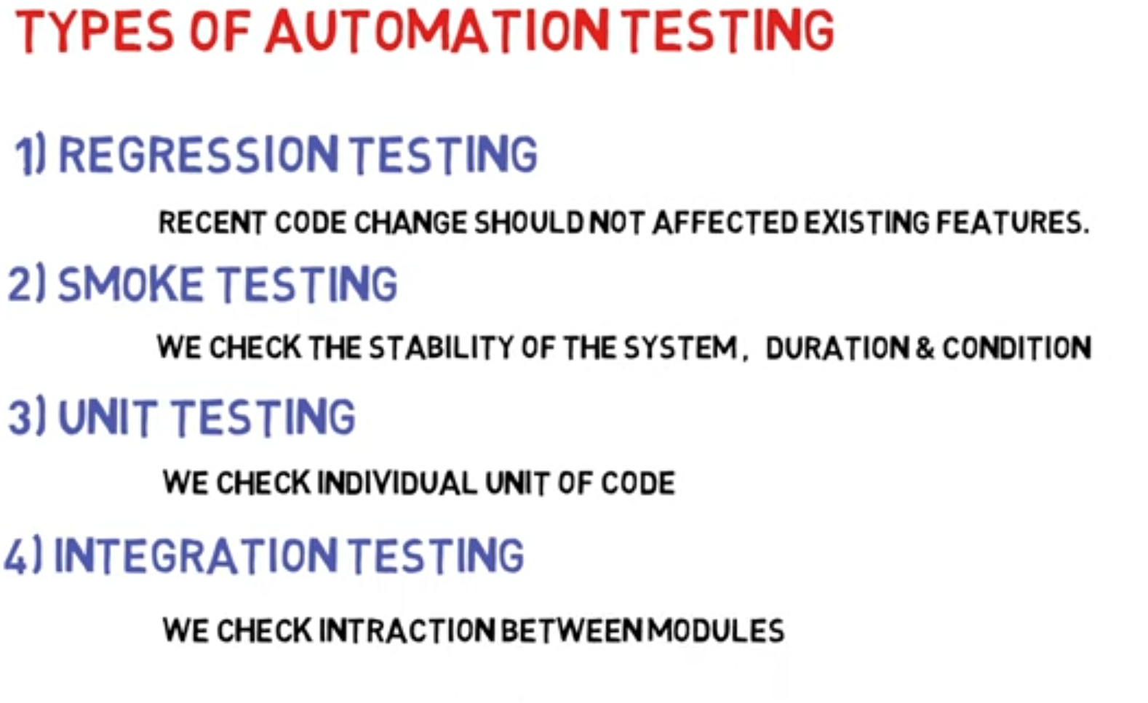

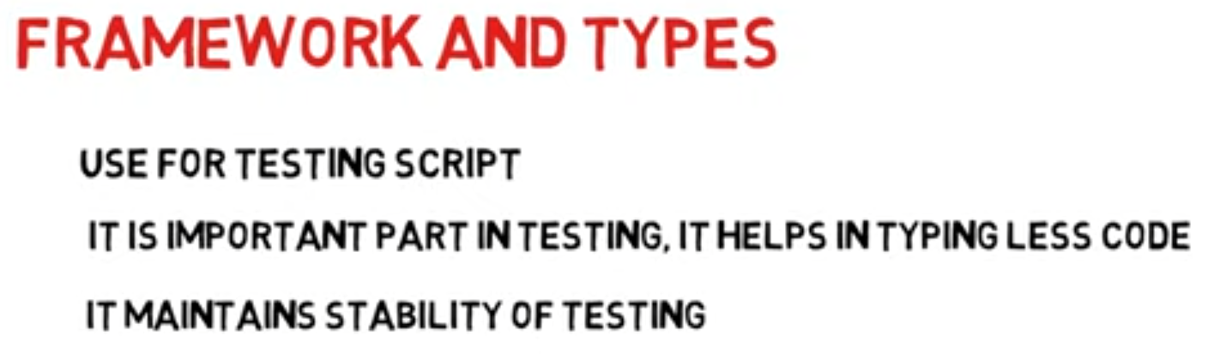

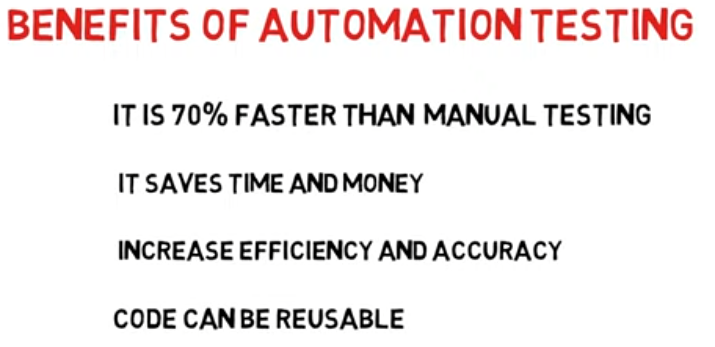

# **Project Management Tools**

To manage the Project management system adequately and efficiently, we use Project management tools.

**Here are some standard tools:**

## Gantt chart

Gantt Chart first developed by Henry Gantt in 1917. Gantt chart usually utilized in project management, and it is one of the most popular and helpful ways of showing activities displayed against time. Each activity represented by a bar.

Gantt chart is a useful tool when you want to see the entire landscape of either one or multiple projects. It helps you to view which tasks are dependent on one another and which event is coming up.

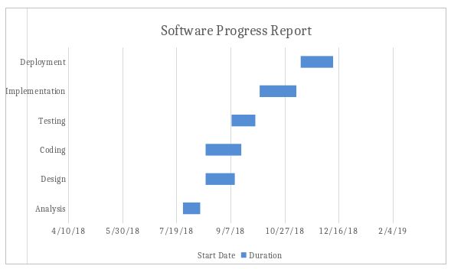

## PERT chart

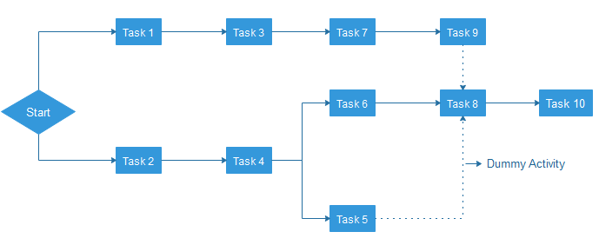

PERT is an acronym of Programme Evaluation Review Technique. In the 1950s, it is developed by the U.S. Navy to handle the Polaris submarine missile programme.

In Project Management, PERT chart represented as a network diagram concerning the number of nodes, which represents events.

The direction of the lines indicates the sequence of the task. In the above example, tasks between "Task 1 to Task 9" must complete, and these are known as a dependent or serial task. Between Task 4 and 5, and Task 4 and 6, nodes are not depended and can undertake simultaneously. These are known as Parallel or concurrent tasks. Without resource or completion time, the task must complete in the sequence which is considered as event dependency, and these are known as Dummy activity and represented by dotted lines.

## Logic Network

The Logic Network shows the order of activities over time. It shows the sequence in which activities are to do. Distinguishing events and pinning down the project are the two primary uses. Moreover, it will help with understanding task dependencies, a timescale, and overall project workflow.

## Critical Path Analysis

Critical path analysis is a technique that is used to categorize the activities which are required to complete a task, as well as classifying the time which is needed to finish each activity and the relationships between the activities. It is also called a critical path method. CPA helps in predicting whether a project will expire on time.